

PARISUTHAM INSTITUTE OF TECHNOLOGY AND SCIENCE

DEPARTMENT OF COMPUTER SCIENCE AND ENGINEERING

SUB CODE: CS8581

SUB NAME: NETWORKS LABORATORY

YEAR / SEMESTER: III / V

PREPARED BY

D.Poovizhi
AP / CSE

DEPARTMENT OF COMPUTER SCIENCE AND ENGINEERING

ACADEMIC YEAR 2022 – 2023 (ODD SEM)

SYLLABUS


Sub. Code | : CS8581 | Branch / Year / Sem : B.E /III /V
Sub.Name | : Networks Laboratory | Batch | : 2020-2024
Staff Name | : Mrs.D.Poovizhi | Academic Year | : 2022-2023 (ODD)

LIST OF EXPERIMENTS

- Learn to use commands like tcpdump, netstat, ifconfig, nslookup and traceroute. Capture ping and traceroute PDUs using a network protocol analyzer and examine.

- Write a HTTP web client program to download a web page using TCP sockets.

- Applications using TCP sockets like:

  - Echo client and echo server

  - Chat

  - File Transfer

- Simulation of DNS using UDP sockets.

- Write a code simulating ARP /RARP protocols.

- Study of Network simulator (NS) and Simulation of Congestion Control Algorithms using NS.
- Study of TCP/UDP performance using Simulation tool.

- Simulation of Distance Vector/ Link State Routing algorithm.

- Performance evaluation of Routing protocols using Simulation tool.

- Simulation of error correction code (like CRC).

TOTAL: 60 PERIODS

DEPARTMENT OF COMPUTER SCIENCE AND ENGINEERING

ACADEMIC YEAR 2022 – 2023 (ODD SEM)

Sub. Code | : CS8581 | Branch / Year / Sem : B.E /III /V
Sub.Name | : Networks Laboratory | Batch | : 2020-2024
Staff Name | : Mrs.D.Poovizhi | Academic Year | : 2022-2023 (ODD)

COURSE OBJECTIVE

- To learn and use network commands.

- To learn socket programming.

- To implement and analyze various network protocols.

- To learn and use simulation tools

- To use simulation tools to analyze the performance of various network protocols

At the end of the course, the student should be able to

- Implement various protocols using TCP and UDP.

- Compare the performance of different transport layer protocols.

- Use simulation tools to analyze the performance of various network protocols.

- Analyze various routing algorithms

- Implement error correction codes.

PRE-REQUISITE

1. Knowledge in C/C++/JAVA.

EQUIPMENTS / COMPONENTS / SOFTWARE REQUIRMENT HARDWARE:

- Standalone desktops

SOFTWARE:

- C / C++ / Java / Python / Equivalent Compiler

- Network simulator like NS2/Glomosim/OPNET/ Packet Tracer / Equivalent

 | CS8581 NETWORKS LABORATORY
EX.NO:1(a) | NETWORKING COMMANDS
DATE : | (tcpdump, netstat, ifconfig, nslookup and traceroute)

Aim: To study the different networking commands

    - tcpdump

    - netstat

    - ifconfig

    - nslookup and

    - Traceroute

Description

- tcpdump

  - tcpdump is a most powerful and widely used command-line packets sniffer or package analyzer tool which is used to capture or filter TCP/IP packets that received or transferred over a network on a specific interface.

  - It is available under most of the Linux/Unix based operating systems.

  - tcpdump also gives us a option to save captured packets in a file for future analysis.

  - It saves the file in a pcapformat, that can be viewed by tcpdump command or a open source

GUI based tool called Wireshark (Network Protocol Analyzier) that reads tcpdump pcap format files.

Prerequisite to capture packet on windows:

- Windump – Its Windows version of tcpdump

- WinCap – it allows applications to capture and transmit network packets.

- Wireshark – to open the pcap file need Wireshark.

Steps

- Download Windump

- Download WinPcap

- Download wireshark Procedure

Step 1: Download and install above software.

Step 2: Open a Command Prompt with Administrator Rights & go to the folder where windump is located.

NL 1 PITS/CSE/III YR/NL

CS8581 NETWORKS LABORATORY
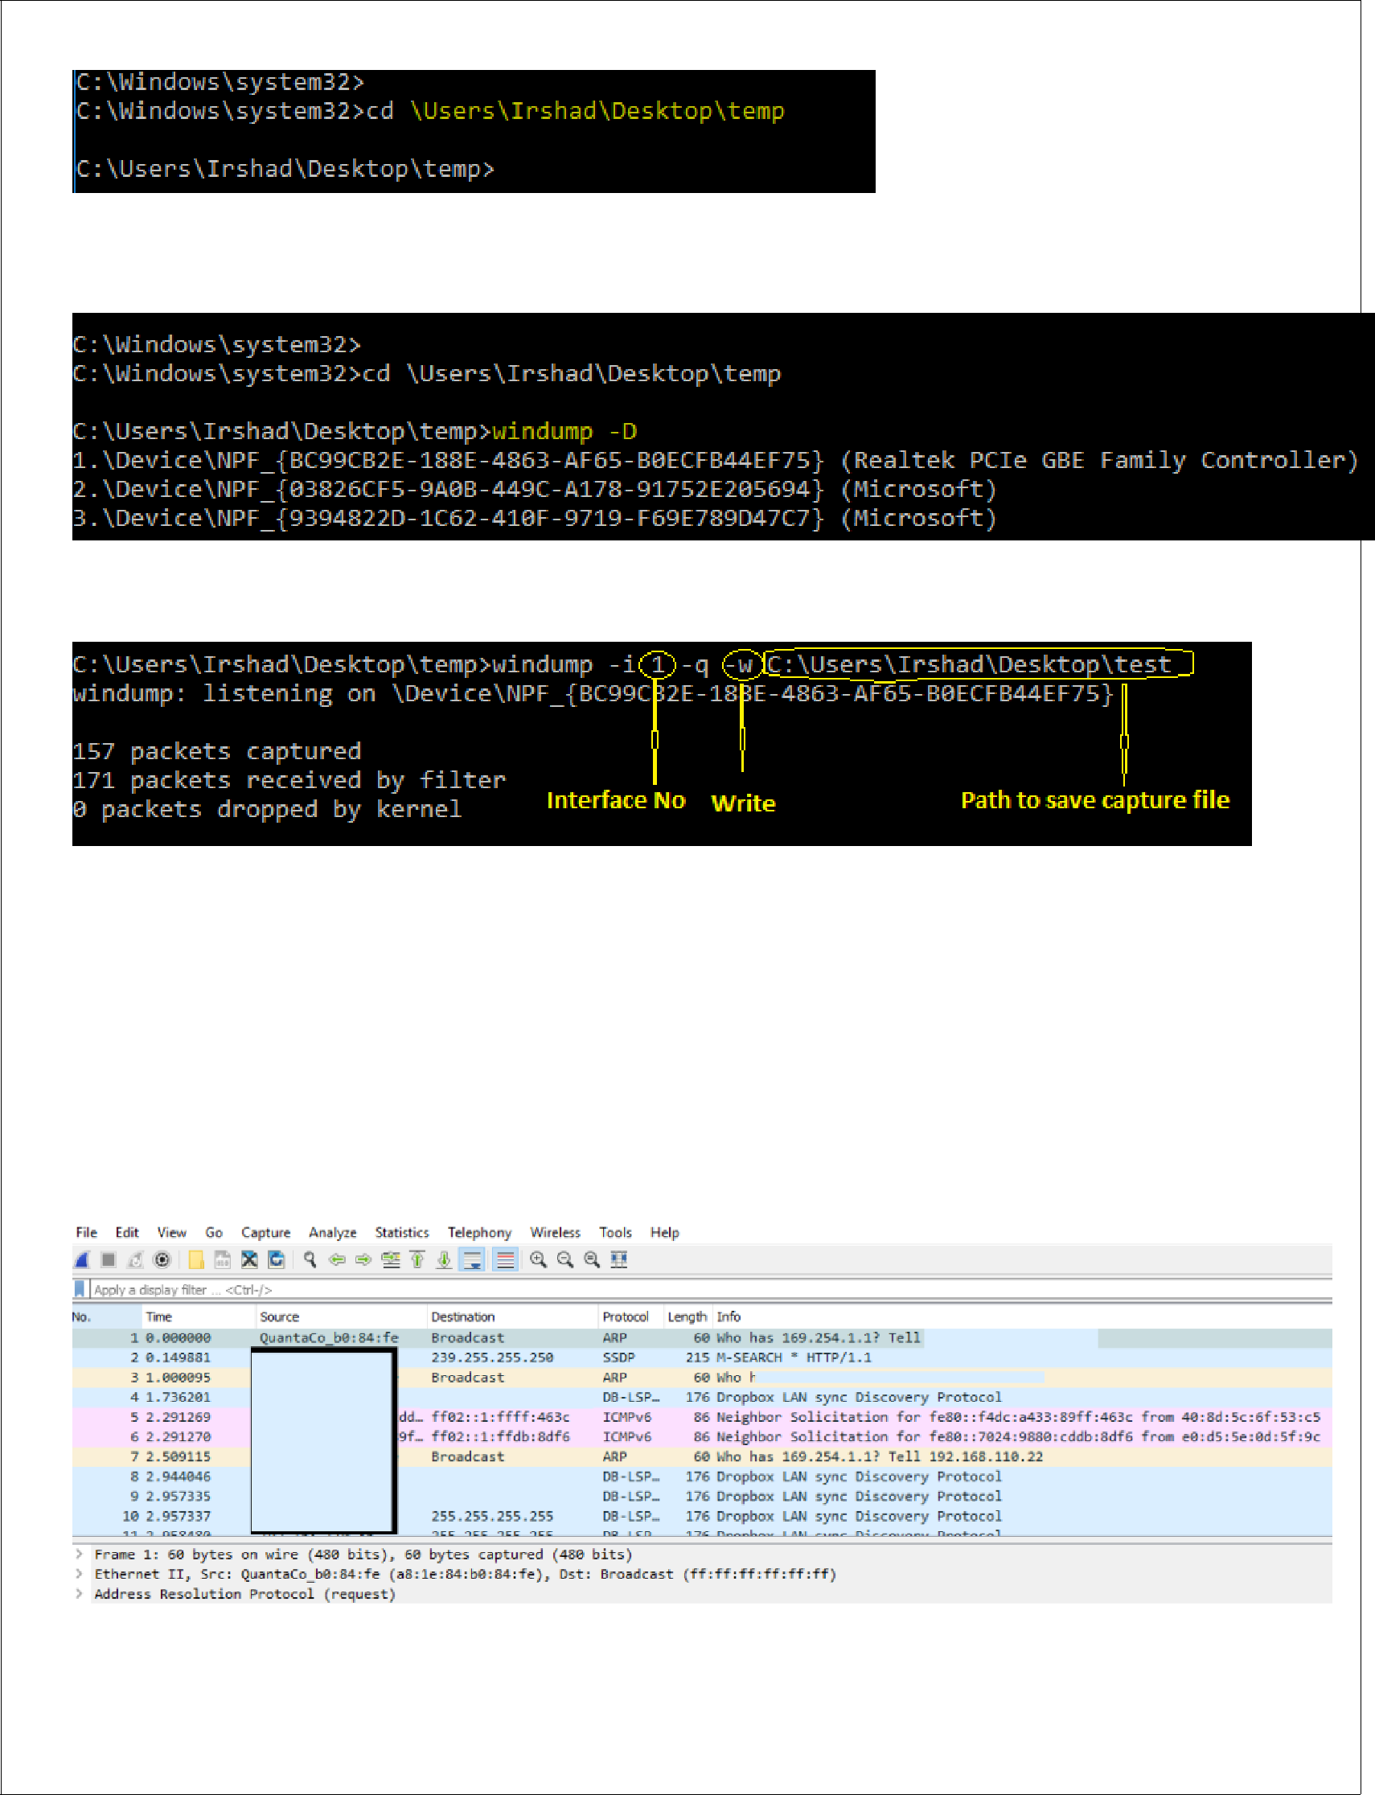

Step 3 -> First determine the ID of the Network Interface Card (NIC). The following command lists the set of NICs: windump -D

Step 4 -> type below command

Where :

- -i is the interface no (i.e 1)

- -q is quit mode

- -w – Write – to write the capture logs

- -r – Read – to see capture logs on console window

- path where you want to save the capture file.

Now change the file name extension with (.pcap ) and open with wireshark

NL 2 PITS/CSE/III YR/NL
CS8581 NETWORKS LABORATORY

- netstat

  - The netstat command, meaning network statistics, is a Command Prompt command used to display very detailed information about how our computer is communicating with other computers or network devices.

  - Specifically, the netstat command can show details about individual network connections, overall and protocol-specific networking statistics, and much more, all of which could help troubleshoot certain kinds of networking issues.

  - Netstat provides statistics for the following:

- Proto - The name of the protocol (TCP or UDP).

- Local Address - The IP address of the local computer and the port number being used. The name of the local computer that corresponds to the IP address and the name of the port is shown unless the -n parameter is specified. If the port is not yet established, the

port number is shown as an asterisk (*).

  - Foreign Address - The IP address and port number of the remote computer to which the socket is connected. The names that corresponds to the IP address and the port are shown unless the -n parameter is specified. If the port is not yet established, the port number is shown as an asterisk (*).

- Indicates the state of a TCP connection. The possible states are as follows:

State | Description
CLOSED | Indicates that the server has received an ACK signal from the client and the connection is
 | closed
CLOSE_WAIT | Indicates that the server has received the first FIN signal from the client and the
 | connection is in the process of being closed
ESTABLISHED | Indicates that the server received the SYN signal from the client and the session is
 | established
FIN_WAIT_1 | Indicates that the connection is still active but not currently being used
FIN_WAIT_2 | Indicates that the client just received acknowledgment of the first FIN signal from the
 | server
LAST_ACK | Indicates that the server is in the process of sending its own FIN signal
LISTENING | Indicates that the server is ready to accept a connection
SYN_RECEIVED | Indicates that the server just received a SYN signal from the client
SYN_SEND | Indicates that this particular connection is open and active

NL 3 PITS/CSE/III YR/NL

CS8581 NETWORKS LABORATORY

Syntax : netstat [-a] [-e] [-n] [-o] [-p Protocol] [-r] [-s] [Interval]
Used without |  |  | displays active TCP connections.
parameters
 | -a |  | Displays all active TCP connections and the TCP and UDP ports on which the computer is
 |  |  | listening.
 | -e |  | Displays Ethernet statistics, such as the number of bytes and packets sent and received. This
 |  |  | parameter can be combined with -s.
 | -n |  | Displays active TCP connections, however, addresses and port numbers are expressed
 |  |  | numerically and no attempt is made to determine names.
 |  |  | Displays active TCP connections and includes the process ID (PID) for each connection. You
 | -o |  | can find the application based on the PID on the Processes tab in Windows Task Manager.
 |  |  | This parameter can be combined with -a, -n, and -p.
 |  |  | Shows connections for the protocol specified by Protocol. In this case, the Protocol can be
 | -p |  | tcp, udp, tcpv6, or udpv6. If this parameter is used with -s to display statistics by protocol,
 |  |  | Protocol can be tcp, udp, icmp, ip, tcpv6, udpv6, icmpv6, or ipv6.
 |  |  | Displays statistics by protocol. By default, statistics are shown for the TCP, UDP, ICMP, and
 | -s |  | IP protocols. If the IPv6 protocol for Windows XP is installed, statistics are shown for the
 |  |  | TCP over IPv6, UDP over IPv6, ICMPv6, and IPv6 protocols. The -p parameter can be used to
 |  |  | specify a set of protocols.
 | -r |  | Displays the contents of the IP routing table. This is equivalent to the route print command.
Interval |  |  | Redisplays the selected information every Interval seconds. Press CTRL+C to stop the
 |  |  | redisplay. If this parameter is omitted, netstat prints the selected information only once.
 | /? |  | - Displays help at the command prompt.
Examples
S.No |  | Command |  | Description
1. |  | netstat -b |  | To find out which programs are making connections with the outside world
2. |  | netstat -f |  | Shows all active TCP connections.
3. |  | netstat -o |  | Display Connection or Ports Process ID
4. |  | netstat -an |  | The -a parameter lists all the computer’s connections and listening ports, while the -
4. |  |  |  | n parameter displays addresses and port numbers in numerical format.
5. |  | netstat –s |  | To find out for any received header error, received address error, discarded packet,
5. |  |  |  | etc. It will list out statistics from IPv4, IPv6, ICMPv4, ICMPv6, TCP, UDP, etc.
6. |  | netstat –r |  | To display Route Table
7. |  | netstat –e |  | To view the status of all interface. This will display Received & Sent details.
8. |  | netstat –f |  | Display Fully Qualified Domain Name
9. |  | netstat –n |  | Displays addresses and port numbers in numerical form.
10. |  | netstat -a |  | Display All TCP and UDP Connections with Listening Ports

NL 4 PITS/CSE/III YR/NL

CS8581 NETWORKS LABORATORY

3. ipconfig

- Displays all current TCP/IP network configuration values and refreshes Dynamic Host Configuration Protocol (DHCP) and Domain Name System (DNS) settings.

- This command is most useful on computers that are configured to obtain an IP address automatically.

- This enables users to determine which TCP/IP configuration values have been configured by DHCP, Automatic Private IP Addressing (APIPA), or an alternate configuration.

- If the Adapter name contains any spaces, use quotation marks around the adapter name (that is, "Adapter Name").

- For adapter names, ipconfig supports the use of the asterisk (*) wildcard character to specify either adapters with names that begin with a specified string or adapters with names that contain a specified string.

- For example, Local* matches all adapters that start with the string Local and *Con* matches all adapters that contain the string Con.

Syntax

ipconfig [/all] [/renew [Adapter]] [/release [Adapter]] [/flushdns] [/displaydns] [/registerdns] [/showclassid Adapter] [/setclassid Adapter [ClassID]]

 | Parameters
 | Used without | displays the IP address, subnet mask, and default gateway for all adapters.
 | parameters
 | /all | Displays the full TCP/IP configuration for all adapters.
 | /renew [Adapter] | Renews DHCP configuration for all adapters (if an adapter is not specified) or for a
 | /renew [Adapter] | specific adapter if the Adapter parameter is included.
 |  | Sends a DHCPRELEASE message to the DHCP server to release the current DHCP
 | /release [Adapter] | configuration and discard the IP address configuration for either all adapters (if an
 |  | adapter is not specified) or for a specific adapter if the Adapter parameter is included.
 | /flushdns | Flushes and resets the contents of the DNS client resolver cache.
 |  | Displays the contents of the DNS client resolver cache, which includes both entries
 | /displaydns | preloaded from the local Hosts file and any recently obtained resource records for name
 |  | queries resolved by the computer.
 | /registerdns | Initiates manual dynamic registration for the DNS names and IP addresses that are
 | /registerdns | configured at a computer.
 |  | Adapter Displays the DHCP class ID for a specified adapter. To see the DHCP class ID for
 | /showclassid | all adapters, use the asterisk (*) wildcard character in place of Adapter. This parameter is
 | /showclassid | available only on computers with adapters that are configured to obtain an IP address
 |  | automatically.
 | /setclassid | Adapter [ClassID] Configures the DHCP class ID for a specified adapter. To set the DHCP
 | /setclassid | class ID for all adapters, use the asterisk (*) wildcard character in place of Adapter.
 | NL 5 | PITS/CSE/III YR/NL

 |  | CS8581 NETWORKS LABORATORY
 | Examples:
 | ipconfig | To display the basic TCP/IP configuration for all adapters
 | ipconfig /all | To display the full TCP/IP configuration for all adapters
 | ipconfig /renew "Local Area | To renew a DHCP-assigned IP address configuration for only the
 | Connection" | Local Area Connection adapter
 | ipconfig /flushdns | To flush the DNS resolver cache when troubleshooting DNS name
 |  | resolution problems
 | ipconfig /showclassid Local | To display the DHCP class ID for all adapters with names that start
 |  | with Local
 | ipconfig /setclassid "Local Area | To set the DHCP class ID for the Local Area Connection adapter to
 | Connection" TEST | TEST

- nslookup

  - nslookup is the name of a program that lets an Internet server administrator or any computer user enter a host name (for example, "whatis.com") and find out the corresponding IP address.

  - It will also do reverse name lookup and find the host name for an IP address you specify.

Description | Command
Finding The IP Address of an Host | nslookup www.google.com
Reverse Lookup IP address to domain name | nslookup IP address
 | nslookup 82.165.119.51
Find Mail Servers for a Domain | slookup -querytype=mx domain name
 | nslookup -querytype=mx www.google.com

- Traceroute

  - Traceroute is a network diagnostic tool that displays the route taken by packets across a network and measures any transit delays.

Syntax : tracert domain name

Example : tracert google.com

tracert 64.13.192.208

Result

Thus a study on different networking commands were made successfully

NL 6 PITS/CSE/III YR/NL

 | CS8581 NETWORKS LABORATORY
EX.NO:1(b) | EXAMINING THE PING AND TRACEROUTE PDUS USING A NETWORK
DATE: | PROTOCOL ANALYZER (WIRESHARK)
AIM

To examine the ping and traceroute PDU’s using a network protocol analyzer

Description

- Wireshark is a free and open source packet analyzer used for network troubleshooting and analysis.

- The following activities will show us how to use Wireshark to capture and analyze tracert/traceroute traffic.

- Tracing routes is accomplished through the use of Internet Control Message Protocol (ICMP) Time Exceeded.

Preparation

To prepare for this activity:

- Start Windows.

- Log in if necessary.

- Install Wireshark.

Activity 1 - Capture Tracert Traffic

To capture ICMP tracert traffic:

- Start a Wireshark capture.

- Open a command prompt.

- Type tracert -d 8.8.8.8 and press Enter to trace the route to one of Google's public DNS servers. The -d option prevents DNS name resolution, which in this case will improve performance and reduce the amount of captured traffic.

- When the trace is complete, close the command prompt.

- Stop the Wireshark capture.

Activity 2 - Analyze Tracert Traffic

To analyze tracert traffic:

- Observe the traffic captured in the top Wireshark packet list pane. Look for traffic with ICMP listed as the protocol. To view only ICMP traffic, type icmp (lower case) in the Filter box and press Enter.

- Select the first ICMP packet, labeled Echo (ping) request.

- Observe the packet details in the middle Wireshark packet details pane.

NL 7 PITS/CSE/III YR/NL

CS8581 NETWORKS LABORATORY

- Expand Internet Protocol Version 4 to view IPv4 details.

- Observe the Time to live. Notice that the time to live is set to 1.

- Expand Internet Control Message Protocol to view ICMP details.

- Observe the Type. Notice that the type is 8 (Echo (ping) request). Tracert is performed through a series of ICMP Echo requests, varying the Time-To-Live (TTL) until the destination is found.

- In the top Wireshark packet list pane, select the second ICMP packet, labeled Time-to-live exceeded.

- Observe the packet details in the middle Wireshark packet details pane. Notice that it is an Ethernet II / Internet Protocol Version 4 / Internet Control Message Protocol frame.

- Expand Internet Protocol Version 4 to view IPv4 details.

- Observe the Source. This is the IP address of the router where the time was exceeded.

- Expand Internet Control Message Protocol to view ICMP details.

- Observe the Type. Notice that the type is 11 (Time-to-live exceeded).

- Observe the Code. Notice that the code is 0 (Time to live exceeded in transit).

- Observe the fields that follow. Notice that the contents of the request packet are returned with the time exceeded error.

- Continue selecting alternate ICMP Echo Request and ICMP Time-To-Live Exceeded packets. Notice that the request is repeated three times for each time-to-live count, and each reply indicates the IP address of the router where the time to live was exceeded.

- Close Wireshark to complete this activity. Quit without Saving to discard the captured traffic.

RESULT

Thus the Tracert Traffic is captured and analyzed using wireshark

NL 8 PITS/CSE/III YR/NL

CS8581 NETWORKS LABORATORY

VIVA QUESTIONS

1. Tell about the tcpdump command

2. Differentiate ping and traceroute command

3. Write about network protocol analyzer

4. Give some examples for network protocol analyzer

5. Write about ipconfig

Staff Signature

NL 13 PITS/CSE/III YR/NL

CS8581 NETWORKS LABORATORY

EX.NO:2 HTTP WEB CLIENT PROGRAM TO DOWNLOAD A WEB PAGE USING TCP SOCKETS DATE:

AIM:

To write a HTTP web client program to download a web page using TCP sockets in python.

ALGORITHM

- Create socket

- Get server IP address from domain name

- Connect to server using IP address

- Send request to server

- Receive data (webpage)

PROGRAM

import socket

request = b"GET / HTTP/1.1\nHost: google.com\n\n"

- = socket.socket(socket.AF_INET, socket.SOCK_STREAM) s.connect(("google.com", 80))

s.send(request) result = s.recv(10000) while (len(result) > 0):

print(result)

result = s.recv(10000)

NL 14 PITS/CSE/III YR/NL

CS8581 NETWORKS LABORATORY

Sample Output

HTTP/1.1 301 Moved Permanently

Location: http://www.google.com/

Content-Type: text/html; charset=UTF-8

Date: Sat, 13 Apr 2019 07:00:51 GMT

Expires: Mon, 13 May 2019 07:00:51 GMT

Cache-Control: public, max-age=2592000

Server: gws

Content-Length: 219

X-XSS-Protection: 0

X-Frame-Options: SAMEORIGIN

Age: 10184

X-Cache: HIT from tg22819a

X-Cache-Lookup: HIT from tg22819a:3120

Via: 1.1 tg22819a (squid/3.5.20)

Connection: keep-alive

<HTML><HEAD><meta http-equiv="content-type" content="text/html;charset=utf-8"> <TITLE>301 Moved</TITLE></HEAD><BODY> <H1>301 Moved</H1>

The document has moved

<A HREF="http://www.google.com/">here</A>.

</BODY></HTML>

RESULT

Thus the HTTP web client program to download a web page using TCP sockets was executed and output was verified.

NL 15 PITS/CSE/III YR/NL

CS8581 NETWORKS LABORATORY

VIVA QUESTIONS

1. Define socket

2. What do you mean by web server?

3. Write about web client

4. Tell about TCP

5. Differentiate between TCP and UDP

Staff Signature

NL 16 PITS/CSE/III YR/NL

CS8581 NETWORKS LABORATORY

EX.NO. 3 (a) TCP SOCKET APPLICATION -ECHO CLIENT AND ECHO SERVER
DATE :

AIM

To write a Java program for ECHO using TCP Sockets

ALGORITHM

Client Side Programming

- Establish a Socket Connection

o To connect to other machine we need a socket connection.

o A socket connection means the two machines have information about each other’s network location (IP Address) and TCP port.

o The java.net.Socket class represents a Socket.

o To open a socket: Socket socket = new Socket(“127.0.0.1”, 5000)

o First argument – IP address of Server. ( 127.0.0.1 is the IP address of localhost, where code will run on single stand-alone machine).

o Second argument – TCP Port. (Just a number representing which application to run on a server. o For example, HTTP runs on port 80. Port number can be from 0 to 65535)

- Communication

o To communicate over a socket connection, streams are used to both input and output the data.

- Closing the connection

o The socket connection is closed explicitly once the message to server is sent.

o In the program, Client keeps reading input from user and sends to the server until “Over” is typed.

- A Java program for a Client
import java.net.*;

import java.io.*; public class Client

{

- initialize socket and input output streams private Socket socket = null;
private DataInputStream input = null;

private DataOutputStream out = null;

public Client(String address, int port)

{

- establish a connection 0s 0,
NL 17 PITS/CSE/III YR/NL

try
{

socket = new Socket(address, port);

System.out.println("Connected");

// takes input from terminal

input = new DataInputStream(System.in);

// sends output to the socket

out = new DataOutputStream(socket.getOutputStream());

}

catch(UnknownHostException u)

{

System.out.println(u);

}

catch(IOException i)

{

System.out.println(i);

}

// string to read message from input

String line = "";

while (!line.equals("Over"))

{

try

{

line = input.readLine();

out.writeUTF(line);

}

catch(IOException i)

{

System.out.println(i);

}

}

try

{

input.close();

out.close();

socket.close();

}

catch(IOException i)

{

System.out.println(i);

}

}

public static void main(String args[])

{

Client client = new Client("127.0.0.1", 5000);

} }

CS8581 NETWORKS LABORATORY

Server Programming

- Establish a Socket Connection

- To write a server application two sockets are needed.

  - A ServerSocket which waits for the client requests (when a client makes a new Socket())

  - A plain old Socket socket to use for communication with the client.

- Communication

  - getOutputStream() method is used to send the output through the socket.

- Close the Connection

  - After finishing, it is important to close the connection by closing the socket as well as input/output streams.

import java.net.*;

import java.io.*;

public class Server

{

//initialize socket and input stream

private Socket socket = null;

private ServerSocket server = null;

private DataInputStream in= null;

- constructor with port public Server(int port)
{

  - starts server and waits for a connection try
{

server = new ServerSocket(port); System.out.println("Server started");

System.out.println("Waiting for a client ...");

socket = server.accept();

System.out.println("Client accepted");

- takes input from the client socket in = new DataInputStream(
new BufferedInputStream(socket.getInputStream())); String line = "";

  - reads message from client until "Over" is sent

while (!line.equals("Over"))

{

NL 19 PITS/CSE/III YR/NL

CS8581 NETWORKS LABORATORY

try

{

line = in.readUTF();

System.out.println(line);

}

catch(IOException i)

{

System.out.println(i);

} }

System.out.println("Closing connection");

- close connection socket.close(); in.close();

}

catch(IOException i)

{

System.out.println(i);

}

}

public static void main(String args[])

{

Server server = new Server(5000);

} }

OUTPUT

Open two windows one for Server and another for Client

1. First run the Server application as , $ java Server

Server started

Waiting for a client …

2. Then run the Client application on another terminal as, $ java Client

It will show – Connected and the server accepts the client and shows,

Client accepted

- Then start typing messages in the Client window. Here is a sample input to the Client Hello

I made my first socket connection Over
Which the Server simultaneously receives and shows, Hello

I made my first socket connection Over

Closing connection

Sending “Over” closes the connection between the Client and the Server just like said before.

RESULT

Thus the data from client to server is echoed using TCP connection

NL 20 PITS/CSE/III YR/NL

 | CS8581 NETWORKS LABORATORY
EX NO : 3(b) | CHAT APPLICATION USING TCP SOCKETS
DATE :

AIM

To write a java program to initiate a chat between client and server.

ALGORITHM

CLIENT
- Start the program

- Include necessary package in java
- Create a socket in client to server.
- The client establishes a connection to the server.
- The client accept the connection and to send the data from client to server.

- The client communicates the server to send the end of the message
- Stop the program.

SERVER

- Start the program
- Include necessary package in java
- Create a socket in server to client

- The server establishes a connection to the client.
- The server accept the connection and to send the data from server to client and vice versa
- The server communicate the client to send the end of the message.
- Stop the program.

PROGRAM

TCPserver1.java
import java.net.*;

import java.io.*;
public class TCPserver1
{
public static void main(String arg[])

{
ServerSocket s=null;
String line;
DataInputStream is=null,is1=null;

PrintStream os=null;
Socket c=null;
try
{

s=new ServerSocket(9999);
}

catch(IOException e)

{

System.out.println(e);

NL 21 PITS/CSE/III YR/NL

CS8581 NETWORKS LABORATORY

}
try
{
c=s.accept();

is=new DataInputStream(c.getInputStream());
is1=new DataInputStream(System.in);
os=new PrintStream(c.getOutputStream());
do

{
line=is.readLine();
System.out.println("Client:"+line);
System.out.println("Server:");

line=is1.readLine();
os.println(line);
}
while(line.equalsIgnoreCase("quit")==false);

is.close();
os.close();
}
catch(IOException e)
{

System.out.println(e);
}
}
}

TCPclient1.java
import java.net.*;
import java.io.*;
public class TCPclient1

{
public static void main(String arg[])
{
Socket c=null;

String line;
DataInputStream is,is1;
PrintStream os;
try

{
c=new Socket("10.0.200.36",9999);
}
catch(IOException e)
{

System.out.println(e);
}
try
{

os=new PrintStream(c.getOutputStream());
is=new DataInputStream(System.in);
is1=new DataInputStream(c.getInputStream());
do

NL 22 PITS/CSE/III YR/NL

CS8581 NETWORKS LABORATORY

{
System.out.println("Client:");
line=is.readLine();
os.println(line);

System.out.println("Server:" + is1.readLine());
}
while(line.equalsIgnoreCase("quit")==false);
is1.close();

os.close();
}
catch(IOException e)
{

System.out.println("Socket Closed!Message Passing is over");
}}

OUTPUT:
SERVER
C:\Program Files\Java\jdk1.5.0\bin>javac TCPserver1.java

Note: TCPserver1.java uses or overrides a deprecated API.
Note: Recompile with -deprecation for details.
C:\Program Files\Java\jdk1.5.0\bin>java TCPserver1
Client: Hai Server

Server:Hai Client
Client: How are you
Server:Fine
Client: quit
Server:quit

CLIENT

C:\Program Files\Java\jdk1.5.0\bin>javac TCPclient1.java
Note: TCPclient1.java uses or overrides a deprecated API.
Note: Recompile with -deprecation for details.
C:\Program Files\Java\jdk1.5.0\bin>java TCPclient1
Client:Hai Server

Server: Hai Client
Client:How are you
Server: Fine
Client:quit
Server: quit

RESULT

Thus the CHAT program was successfully executed.

NL 23 PITS/CSE/III YR/NL

CS8581 NETWORKS LABORATORY

EX.NO. 3(C) FILE TRANSFER USING TCP SOCKETS

DATE :

AIM

To create a socket (TCP) between two computers and enable file transfer between them.

ALGORITHM

Server

- Start the program.

- Create a socket with address family AF_INET, type SOCK_STREAM and default protocol.

- Initialize the socket and set its attributes assign any port number as desired.

- Bind the server to the socket using bind() function.

- Establish the listen queue using the listen function.

- Wait for client program on request, establish a connection using accept function.

- Repeat steps 8-10 until the server sends bye.

- Read the message from the client using read() function. display the message.

- If the client message is bye go to step 11.

- Accept the server message and write it to client using write() function.

- Close the connection.

- Stop the program.

- Start the program.

- Create a socket with address family AF_INET type SOCK_STERAM and default protocol.

- Initialize the socket and set it attributes set the required port number.

- Connect to the server using connect() function to initialize the request.

- Repeat steps 6-8 until server sends bye

- Accept the client message and write it to the server using write function.

- If the client message is bye go to step 9.

- Read the message from the server using read() function. Display the message.

- Stop the program.

SERVER PROGRAM

TCPSERVER

#include<sys/types.h>

#include<sys/socket.h>

#include<netinet/in.h>

#include<sys/stat.h>

#include<unistd.h>

#include<stdlib.h>

#include<stdio.h>

#include<fcntl.h>

NL 24 PITS/CSE/III YR/NL

CS8581 NETWORKS LABORATORY

int main()

{

int cont,create_socket,new_socket,addrlen,fd;

int bufsize = 1024;

char *buffer = malloc(bufsize);

char fname[256];

struct sockaddr_in address;

if ((create_socket = socket(AF_INET,SOCK_STREAM,0)) > 0) printf("The socket was created\n"); address.sin_family = AF_INET; address.sin_addr.s_addr = INADDR_ANY; address.sin_port = htons(8000);

if (bind(create_socket,(struct sockaddr*)&address,sizeof(address)) == 0)

printf("Binding Socket\n");

listen(create_socket,3);

addrlen = sizeof(struct sockaddr_in);

new_socket = accept(create_socket,(struct sockaddr*)&address,&addrlen); if (new_socket > 0)

printf("The Client %s is Connected...\n",inet_ntoa(address.sin_addr)); recv(new_socket,fname, 255,0);

printf("A request for filename %s Received..\n", fname); if ((fd=open(fname, O_RDONLY))<0) {perror("File Open Failed"); exit(0);}

while((cont=read(fd, buffer, bufsize))>0)

{

send(new_socket,buffer,cont,0);

}

printf("Request Completed\n");

close(new_socket);

return close(create_socket);

}

CLIENT PROGRAM:

TCPCLIENT

#include<sys/socket.h>

#include<sys/types.h>

#include<netinet/in.h>

#include<unistd.h>

#include<stdlib.h>

#include<stdio.h>

int main(int argc,char *argv[])

{

int create_socket,cont;

int bufsize = 1024;

char *buffer = malloc(bufsize);

NL 25 PITS/CSE/III YR/NL

CS8581 NETWORKS LABORATORY

char fname[256];

struct sockaddr_in address;

if ((create_socket = socket(AF_INET,SOCK_STREAM,0)) > 0) printf("The Socket was created\n"); address.sin_family = AF_INET; address.sin_port = htons(8000);

inet_pton(AF_INET,argv[1],&address.sin_addr);

if (connect(create_socket,(struct sockaddr *) &address, sizeof(address)) == 0)

printf("The connection was accepted with the server %s...\n",argv[1]); printf("Enter The Filename to Request : "); scanf("%s",fname);

send(create_socket, fname, sizeof(fname), 0);

printf("Request Accepted... Receiving File...\n\n");

printf("The contents of file are...\n\n");

while((cont=recv(create_socket, buffer, bufsize, 0))>0) {

write(1, buffer, cont);

}

printf("\nEOF\n");

return close(create_socket);

}

Output:

Server

[iiiitb031@kings ~]$ cc -o server tcpserver.c

[iiiitb031@kings ~]$ ./server 4235

The socket was created

Binding Socket

The Client 127.0.0.1 is Connected...

A request for filename tcps.c Received.

Request Completed

Client

[iiiitb031@kings ~]$ cc -o client tcpclient.c

[iiiitb031@kings ~]$ ./client 127.0.0.1 4235

The Socket was created

The connection was accepted with the server 127.0.0.1...

Enter The Filename to Request : hello.c

Request Accepted... Receiving File...

The contents of file are...

#include<stdio.h>

void main()

{printf(“\n hello world”);}

EOF

RESULT : Thus the File Transfer Protocol using TCP was successfully executed.

NL 26 PITS/CSE/III YR/NL

CS8581 NETWORKS LABORATORY

VIVA QUESTIONS

1. Define socket programming

2. Why do we need FTP protocol?

- In which layer FTP protocol works?

- How do we open a socket?

5. How do we create an input stream?

Staff Signature

NL 27 PITS/CSE/III YR/NL

CS8581 NETWORKS LABORATORY

EX NO: 4

DATE :

SIMULATION OF DNS USING UDP SOCKETS

AIM

To write a java program for DNS application.

ALGORITHM

Server

- Define an array of hosts and its corresponding IP address in another array

- Create a datagram socket

- Create a datagram packet to receive client request

- Read the domain name from client to be resolved

- Lookup the host array for the domain name

- If found then retrieve corresponding address

- Construct a datagram packet to send response back to the client

- Repeat steps 3-7 to resolve further requests from clients

- Close the server socket

- Stop the program.

- Create a datagram socket

- Get domain name from user

- Construct a datagram packet to send domain name to the server

- Create a datagram packet to receive server message

- If it contains IP address then display it, else display "Domain does not exist"

- Close the client socket

- Stop the program.

PROGRAM

UDP DNS Server

import java.io.*;

import java.net.*;

public class udpdnsserver

{

private static intindexOf(String[] array, String str)

{

str = str.trim();

for (int i=0; i <array.length; i++)

{

if (array[i].equals(str)) return i;

}

return -1;

}

NL 28 PITS/CSE/III YR/NL

CS8581 NETWORKS LABORATORY

public static void main(String arg[])throws IOException {

String[] hosts = {"yahoo.com", "gmail.com","cricinfo.com", "facebook.com"}; String[] ip = {"68.180.206.184", "209.85.148.19","80.168.92.140", "69.63.189.16"}; System.out.println("Press Ctrl + C to Quit"); while (true)

{

DatagramSocketserversocket=new DatagramSocket(1362); byte[] senddata = new byte[1021]; byte[] receivedata = new byte[1021];

DatagramPacketrecvpack = new DatagramPacket(receivedata, receivedata.length); serversocket.receive(recvpack);

String sen = new String(recvpack.getData());

InetAddressipaddress = recvpack.getAddress();

int port = recvpack.getPort();

String capsent;

System.out.println("Request for host " + sen);

if(indexOf (hosts, sen) != -1)

capsent = ip[indexOf (hosts, sen)];

elsecapsent = "Host Not Found";

senddata = capsent.getBytes();

DatagramPacket pack = new DatagramPacket(senddata, senddata.length,ipaddress,port);

serversocket.send(pack);

serversocket.close();

}}}

UDP DNS Client

import java.io.*;

import java.net.*;

public class udpdnsclient

{

public static void main(String args[])throws IOException

{

BufferedReaderbr = new BufferedReader(new InputStreamReader(System.in));

DatagramSocketclientsocket = new DatagramSocket();

InetAddressipaddress;

if (args.length == 0)

ipaddress = InetAddress.getLocalHost();

else

ipaddress = InetAddress.getByName(args[0]);

byte[] senddata = new byte[1024];

byte[] receivedata = new byte[1024];

intportaddr = 1362;

System.out.print("Enter the hostname : ");

NL 29 PITS/CSE/III YR/NL

CS8581 NETWORKS LABORATORY

String sentence = br.readLine(); Senddata =

sentence.getBytes();

DatagramPacket pack = new DatagramPacket(senddata,senddata.length, ipaddress,portaddr); clientsocket.send(pack);

DatagramPacketrecvpack =new DatagramPacket(receivedata,receivedata.length); clientsocket.receive(recvpack);
String modified = new String(recvpack.getData());

System.out.println("IP Address: " + modified);

clientsocket.close();

}}

OUTPUT

Server

$ javac udpdnsserver.java

$ java udpdnsserver

Press Ctrl + C to Quit

Request for host yahoo.com

Request for host cricinfo.com

Request for host youtube.com

Client

$ javac udpdnsclient.java

$ java udpdnsclient

Enter the hostname: yahoo.com

IP Address: 68.180.206.184

$ java udpdnsclient

Enter the hostname: cricinfo.com

IP Address: 80.168.92.140

$ java udpdnsclient

Enter the hostname: youtube.com

IP Address: Host Not Found

RESULT

Thus the program for DNS application was successfully completed.

NL 30 PITS/CSE/III YR/NL

CS8581 NETWORKS LABORATORY

VIVA QUESTIONS

- What is meant by DNS?

- Define datagram.

- Give the categories of DNS and how it is allocated?

- Define TCP and UDP datagram.

- What is the main purpose of a DNS server?

Staff Signature

NL 31 PITS/CSE/III YR/NL

CS8581 NETWORKS LABORATORY

EX.NO:5

DATE :

SIMULATION OF ARP (ADDRESS RESOLUTION PROTOCOL)

REVERSE ADDRESS RESOLUTION PROTOCOL (RARP)

AIM

To write a java program for simulating ARP/RARP protocols

ALGORITHM

Server

- Create a server socket and bind it to port.

- Listen for new connection and when a connection arrives, accept it.

- Send servers date and time to the client.

- Read clients IP address sent by the client.

- Display the client details.

- Repeat steps 2-5 until the server is terminated.

- Close all streams.

- Close the server socket.

  - Stop.

- Create a client socket and connect it to the servers port number.

- Retrieve its own IP address using built-in function.

- Send its address to the server.

- Display the date & time sent by the server.

- Close the input and output streams.

- Close the client socket.

- Stop.

Program for Address Resolution Protocol (ARP) using TCP Client:

import java.io.*;

import java.net.*;

import java.util.*;

class Clientarp

{

public static void main(String args[])

{

try

{

BufferedReader in=new BufferedReader(new InputStreamReader(System.in)); Socket clsct=new Socket("127.0.0.1",139);

DataInputStream din=new DataInputStream(clsct.getInputStream());

DataOutputStream dout=new DataOutputStream(clsct.getOutputStream());

System.out.println("Enter the Logical address(IP):"); String str1=in.readLine();

dout.writeBytes(str1+'\n');

String str=din.readLine();

System.out.println("The Physical Address is: "+str);

NL 32 PITS/CSE/III YR/NL

CS8581 NETWORKS LABORATORY

clsct.close();

}

catch (Exception e)

{

System.out.println(e);

} } }

Server:

import java.io.*;

import java.net.*;

import java.util.*;

class Serverarp

{

public static void main(String args[])

{

try

{

ServerSocket obj=new ServerSocket(139);

Socket obj1=obj.accept();

while(true)

{

DataInputStream din=new DataInputStream(obj1.getInputStream()); DataOutputStream dout=new DataOutputStream(obj1.getOutputStream()); String str=din.readLine();

String ip[]={"165.165.80.80","165.165.79.1"};

String mac[]={"6A:08:AA:C2","8A:BC:E3:FA"};

for(int i=0;i<ip.length;i++)

{

if(str.equals(ip[i]))

{

dout.writeBytes(mac[i]+'\n'); break;

} }

obj.close();

} }

catch(Exception e)

{

System.out.println(e);

} } }

Output:

E:\networks>java Serverarp

E:\networks>java Clientarp

Enter the Logical address(IP): 165.165.80.80

The Physical Address is: 6A:08:AA:C2

NL 33 PITS/CSE/III YR/NL

CS8581 NETWORKS LABORATORY

PROGRAM FOR ADDRESS RESOLUTUION PROTOCOL (RARP) USING UDP

Client:

import java.io.*;

import java.net.*;

importjava.util.*;

class Clientarp12

{

public static void main(String args[])

{

try

{

DatagramSocket client=new DatagramSocket(); InetAddressaddr=InetAddress.getByName("127.0.0.1"); byte[] sendbyte=new byte[1024]; byte[] receivebyte=new byte[1024];

BufferedReader in=new BufferedReader(new InputStreamReader(System.in)); System.out.println("Enter the logical address (IP):"); String str=in.readLine();

sendbyte=str.getBytes();

DatagramPacket sender=new DatagramPacket(sendbyte,sendbyte.length,addr,1309); client.send(sender);

DatagramPacket receiver=new DatagramPacket(receivebyte,receivebyte.length); client.receive(receiver);

String s=new String(receiver.getData());

System.out.println("The Physical Address is(MAC): "+s.trim());

client.close();

}

catch(Exception e)

{

System.out.println(e);

}

}

}

Server:

import java.io.*;

import java.net.*;

importjava.util.*;

class Serverarp12

{

public static void main(String args[])

{

try

{

DatagramSocket server=new DatagramSocket(1309);

NL 34 PITS/CSE/III YR/NL

CS8581 NETWORKS LABORATORY

while(true)

{

byte[] sendbyte=new byte[1024];

byte[] receivebyte=new byte[1024];

DatagramPacket receiver=new DatagramPacket(receivebyte,receivebyte.length); server.receive(receiver);

String str=new String(receiver.getData());

String s=str.trim();

//System.out.println(s);

InetAddressaddr=receiver.getAddress();

int port=receiver.getPort();

String ip[]={"165.165.80.80","165.165.79.1"};

String mac[]={"6A:08:AA:C2","8A:BC:E3:FA"};

for(int i=0;i<ip.length;i++)

{

if(s.equals(ip[i]))

{

sendbyte=mac[i].getBytes();

DatagramPacket sender=new DatagramPacket(sendbyte,sendbyte.length,addr,port);

server.send(sender);

break;

}

}

break;

}

}

catch(Exception e)

{

System.out.println(e);

}

}

}

Output:

E:\networks>java Serverarp12

E:\networks>java Clientarp12

Enter the Physical address (MAC): 6A:08:AA:C2

The Logical Address is(IP): 165.165.80.80

RESULT

Thus the simulation for ARP/RARP was successfully completed.

NL 35 PITS/CSE/III YR/NL

CS8581 NETWORKS LABORATORY

VIVA QUESTIONS

- What is the difference between ARP and RARP?

- To which OSI layer does ARP belong?

3. What is the use of ARP?

4. Sketch the format of an ARP packet?

5. How does ARP resolve an IP address to an Ethernet MAC address?

Staff Signature

NL 36 PITS/CSE/III YR/NL

CS8581 NETWORKS LABORATORY

EX NO : 6

DATE :

STUDY OF NETWORK SIMULATOR (NS) AND SIMULATION OF CONGESTION CONTROL ALGORITHMS

INTRODUCTION TO NS2

- Network Simulator Version 2, widely known as NS2, is an event driven simulation tool that is useful in studying the dynamic nature of communication networks.

- Simulation of wired as well as wireless network functions and protocols (e.g., routing algorithms, TCP, UDP) can be done using NS2.

- In general, NS2 provides users with a way of specifying such network protocols and simulating their corresponding behaviors.

- Due to its flexibility and modular nature, NS2 has gained constant popularity in the networking research community since its birth in 1989.

- Ever since, several revolutions and revisions have marked the growing maturity of the tool, thanks to substantial contributions from the players in the field.

- Among these are the University of California and Cornell University who developed the REAL network simulator, the foundation which NS is based on.

- Since 1995 the Defense Advanced Research Projects Agency (DARPA) supported development of NS through the Virtual InterNetwork Testbed (VINT) project.

- Currently the National Science Foundation (NSF) has joined the ride in development.

- The group of researchers and developers in the community are constantly working to keep NS2 strong and versatile.

FEATURES OF NS2

- It is a discrete event simulator for networking research.

- It provides substantial support to simulate bunch of protocols like TCP, FTP, UDP, https and DSR.

- It simulates wired and wireless network.

- It is primarily Unix based.

- Uses TCL as its scripting language.

- Otcl: Object oriented support

- Tclcl: C++ and otcl linkage

- Discrete event scheduler

NL 37 PITS/CSE/III YR/NL

CS8581 NETWORKS LABORATORY

BASIC ARCHITECTURE OF NS2

- Figure given below shows the basic architecture of NS2.

- NS2 provides users with an executable command ns which takes on input argument, the name of a

- Tcl simulation scripting file.

- Users are feeding the name of a Tcl simulation script (which sets up a simulation) as an input argument of an NS2 executable command ns.

- In most cases, a simulation trace file is created, and is used to plot graph and/or to create animation.
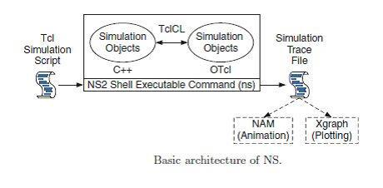

- NS2 consists of two key languages: C++ and Object-oriented Tool Command Language (OTcl).

- While the C++ defines the internal mechanism (i.e., a backend) of the simulation objects, the OTcl sets up simulation by assembling and configuring the objects as well as scheduling discrete events.

- The C++ and the OTcl are linked together using TclCL

Why Two Language? (TCL And C++)

- NS2 stands for Network Simulator Version 2. It is an open-source event-driven simulator designed specifically for research in computer communication networks.

- NS2 uses OTcl to create and configure a network, and uses C++ to run simulation. All C++ codes need to be compiled and linked to create an executable file.

Use OTcl

- For configuration, setup, or one time simulation, or

- To run simulation with existing NS2 modules.

- This option is preferable for most beginners, since it does not involve complicated internal mechanism of NS2. Unfortunately, existing NS2 modules are fairly limited. This option is perhaps not sufficient for most researchers.

NL 38 PITS/CSE/III YR/NL

CS8581 NETWORKS LABORATORY

Use C++

- When we are dealing with a packet, or when we need to modify existing NS2 modules.

- This option perhaps discourages most of the beginners from using NS2. This book particularly aims at helping the readers understand the structure of NS2 and feel more comfortable in modifying NS2 modules.

INSTALLING NS2 ON WINDOWS 7

- NS2 builds and runs under windows using Cygwin. Cygwin provides Linux like environment under windows.

- System Requirements: A computer with C++ compiler. Building full NS2 package requires large memory space approximately 250MB

I. Steps to install NS 2 on windows 7

- Download Cygwin from following link https://www.cygwin.com/setup.exe

- Run the downloaded setup.exe

II. Steps is to install NS2

- Download NS2 from following link: https://www.isi.edu/nsnam/dist/ns-allinone-2.28.tar.gz

- Decompress the file use winrar. Copy the decompressed folder the Cygwin installation directory under the subdirectory home. It will be C:\cygwin\home\system_name : where system_name is name of your system in above Cygwin installation this path will be C:\Cygwin\home\sys27

- Run Cygwin from desktop and change the directory to folder we copied just now in step 2 command to change directory:cd /home/sys27/ns-allinone-2.28
NOTE: please change sys27 to name of your system

- To start installation type following command:"./install"(WITHOUT qoutes)

- Add following lines to the .bashrc

- To check if NS2 is installed correctly run one sample example

To run the example change the directory to examples folder: cd ./home/sys27/ns-allinone-

2.28/ns-tutorial/examples

Then type following command: ns example2.tcl

OVERVIEW

- Starting ns

  - We can start ns with the command 'ns <tclscript>' (assuming that we are in the directory with the ns executable, or that our path points to that directory), where '<tclscript>' is the name of a Tcl script file which defines the simulation scenario.

NL 39 PITS/CSE/III YR/NL

CS8581 NETWORKS LABORATORY

- Starting nam

  - We can either start nam with the command 'nam <nam-file>' where '<nam-file>' is the name of a nam trace file that was generated by ns, or we can execute it directly out of the Tcl simulation script for the simulation which we want to visualize.
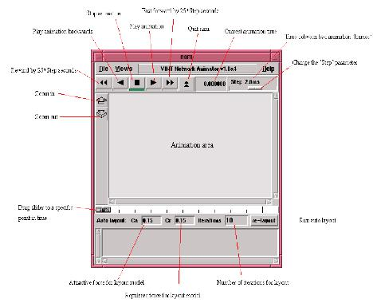

3. The first Tcl script

First of all, we need to create a simulator object. This is done with the command

set ns [new Simulator]

Now we open a file for writing that is going to be used for the nam trace data.

set nf [open out.nam w]

$ns namtrace-all $nf

- The first line opens the file 'out.nam' for writing and gives it the file handle 'nf'.

- In the second line we tell the simulator object that we created above to write all simulation data that is going to be relevant for nam into this file.

NL 40 PITS/CSE/III YR/NL

CS8581 NETWORKS LABORATORY

The next step is to add a 'finish' procedure that closes the trace file and starts nam.

proc finish {} {
global ns nf
$ns flush-trace

close $nf
exec nam out.nam &
exit 0
}

- The next line tells the simulator object to execute the 'finish' procedure after 5.0 seconds of simulation time.

$ns at 5.0 "finish"

- We probably understand what this line does just by looking at it. NS provides us with a very simple way to schedule events with the 'at' command.

The last line finally starts the simulation.

$ns run

4. Two nodes, one link

- We are going to define a very simple topology with two nodes that are connected by a link. The following two lines define the two nodes.

set n0 [$ns node]
set n1 [$ns node]

- A new node object is created with the command '$ns node'. The above code creates two nodes and assigns them to the handles 'n0' and 'n1'. The next line connects the two nodes.

$ns duplex-link $n0 $n1 1Mb 10ms DropTail

- This line tells the simulator object to connect the nodes n0 and n1 with a duplex link with the bandwidth 1Megabit, a delay of 10ms and a DropTail queue.

- Now we can save our file and start the script with 'ns example1.tcl'. nam will be started automatically and we should see an output that resembles the picture below.
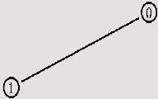

NL 41 PITS/CSE/III YR/NL

CS8581 NETWORKS LABORATORY

5. Sending data

- The next step is to send some data from node n0 to node n1.

- In ns, data is always being sent from one 'agent' to another. So the next step is to create an agent object that sends data from node n0, and another agent object that receives the data on node n1.

#Create a UDP agent and attach it to node n0
set udp0 [new Agent/UDP]
$ns attach-agent $n0 $udp0

  - Create a CBR traffic source and attach it to udp0 set cbr0 [new Application/Traffic/CBR]

$cbr0 set packetSize_ 500 $cbr0 set interval_ 0.005 $cbr0 attach-agent $udp0

- These lines create a UDP agent and attach it to the node n0, then attach a CBR traffic generatot to the UDP agent. CBR stands for 'constant bit rate'. The packetSize is being set to 500 bytes and a packet will be sent every 0.005 seconds (i.e. 200 packets per second).
- The next lines create a Null agent which acts as traffic sink and attach it to node n1.

set null0 [new Agent/Null]
$ns attach-agent $n1 $null0

- Now the two agents have to be connected with each other. $ns connect $udp0 $null0
- And now we have to tell the CBR agent when to send data and when to stop sending.

Note: It's probably best to put the following lines just before the line '$ns at 5.0 "finish"'.

$ns at 0.5 "$cbr0 start"
$ns at 4.5 "$cbr0 stop"

6. The topology

- The first step is to define the topology. Now insert the following lines into the code to create four nodes.

set n0 [$ns node]
set n1 [$ns node]
set n2 [$ns node]

set n3 [$ns node]

- The following piece of Tcl code creates three duplex links between the nodes.

$ns duplex-link $n0 $n2 1Mb 10ms DropTail
$ns duplex-link $n1 $n2 1Mb 10ms DropTail
$ns duplex-link $n3 $n2 1Mb 10ms DropTail

NL 42 PITS/CSE/III YR/NL

CS8581 NETWORKS LABORATORY

- Add the next three lines to our Tcl script and start it again.

$ns duplex-link-op $n0 $n2 orient right-down

$ns duplex-link-op $n1 $n2 orient right-up
$ns duplex-link-op $n2 $n3 orient right

- It should look like the picture below.
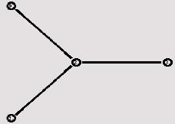

7. The events

- Now we create two UDP agents with CBR traffic sources and attach them to the nodes n0 and n1. Then we create a Null agent and attach it to node n3.

#Create a UDP agent and attach it to node n0

set udp0 [new Agent/UDP]
$ns attach-agent $n0 $udp0

- Create a CBR traffic source and attach it to udp0 set cbr0 [new Application/Traffic/CBR]

$cbr0 set packetSize_ 500 $cbr0 set interval_ 0.005 $cbr0 attach-agent $udp0

#Create a UDP agent and attach it to node n1
set udp1 [new Agent/UDP]
$ns attach-agent $n1 $udp1

# Create a CBR traffic source and attach it to udp1 set cbr1 [new Application/Traffic/CBR]

$cbr1 set packetSize_ 500 $cbr1 set interval_ 0.005 $cbr1 attach-agent $udp1 set null0 [new Agent/Null] $ns attach-agent $n3 $null0

- The two CBR agents have to be connected to the Null agent. $ns connect $udp0 $null0

$ns connect $udp1 $null0

NL 43 PITS/CSE/III YR/NL

CS8581 NETWORKS LABORATORY

- We want the first CBR agent to start sending at 0.5 seconds and to stop at 4.5 seconds while the second CBR agent starts at 1.0 seconds and stops at 4.0 seconds.

$ns at 0.5 "$cbr0 start"
$ns at 1.0 "$cbr1 start"
$ns at 4.0 "$cbr1 stop"

$ns at 4.5 "$cbr0 stop"

- There is more traffic on the links from n0 to n2 and n1 to n2 than the link from n2 to n3 can carry. A simple calculation confirms this: We are sending 200 packets per second on each of the first two links and the packet size is 500 bytes. This results in a bandwidth of 0.8 megabits per second for the links from n0 to n2 and from n1 to n2. That's a total bandwidth of 1.6Mb/s, but the link between n2 and n3 only has a capacity of 1Mb/s, so obviously some packets are being discarded. But which ones? Both flows are black, so the only way to find out what is happening to the packets is to monitor them in nam by clicking on them

8. Marking flows

- Add the following two lines to your CBR agent definitions.

$udp0 set class_ 1
$udp1 set class_ 2

- The parameter 'fid_' stands for 'flow id'. Now add the following piece of code to our Tcl script, preferably at the beginning after the simulator object has been created, since this is a part of the simulator setup.

$ns color 1 Blue
$ns color 2 Red
- This code allows us to set different colors for each flow id.
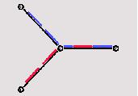

9. Monitoring a queue

- We have to add the following line to our code to monitor the queue for the link from n2 to n3. $ns duplex-link-op $n2 $n3 queuePos 0.5

- Start ns again and we will see a picture similar to the one below after a few moments.
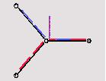

NL 44 PITS/CSE/III YR/NL

CS8581 NETWORKS LABORATORY

ADVANTAGES AND DISADVANTAGES OF NS2

Advantages

- Cheap- Does not require costly equipment

- Complex scenarios can be easily tested.

- Results can be quickly obtained-more ideas can be tested in a smaller time frame.

- Supported protocols

- Supported platforms

- Modularity

- Popular

Disadvantages

- Real system too complex to model. i.e. complicated structure.

- Bugs are unreliable

SUMMARY

LANGUAGE USED WITH NS2:System Language: C, C++, JAVA

SCRIPTING LANGUAGE:

- Rapid high level programming

- Type less to simplify connection between components.

- Interpreted system. Less efficient.

- Network animator used to visualize wired simulations.

- Ad-hockey used to visualize wired simulations.

LINKS:

- Simplex

- Duplex

TRAFFIC GENERATORS:

- Source: An Agent which is originator of packets.

- Sink: An Agent which is the destination of these packets.

SIMULATION IN NS2:

• Creating the event scheduler. • Creating Traffic.

• Creating Network. • Tracking.

- Creating connections.

FOR WIRELESS SIMULATION:

- Configure the node before creating the network creating connection.

- UDP:

  - Set UDP[new agent/UDP]

  - Set NULL[new agent/NULL]

  - $ns attach-agent $no $udp

  - $ns attach-agent $no $null

  - $ns connect $udp $null

NL 45 PITS/CSE/III YR/NL

CS8581 NETWORKS LABORATORY

SIMULATION OF CONGESTION CONTROL ALGORITHMS USING NS2

AIM

To simulate Congestion Control algorithm in TCP using NS2.

ALGORITHM:

- Create a simulator object

- Tell the simulator to use link state routing

- Open the nam trace file

- Define a 'finish' procedure

- Close the trace file

- Execute nam on the trace file

- Create six nodes

- Create links between the nodes.

- Data transmission between the sender1 and receiver1 is created using the tcp connection and FTP application.
- Data transmission between the sender2 and receiver2 is created using the udp agent and CBR traffic.

- Congestion occurs at the link between router1 and router2 (bottleneck link) due to the high data flow rate that exceeds the link capacity.

- The length of the queue is limited.

- TCP enforces congestion control mechanism automatically by adjusting the sending data rate according to the acknowledgment arrival time.

- Schedule events for the CBR agent and the network dynamics

- Call the finish procedure after 5 seconds of simulation time

- Run the simulation

PROGRAM:

#Create a simulator object

set ns [new Simulator]

#Define different colors for data flows (for NAM )
$ns color 1 Blue

$ns color 2 Red

#Open the NAM trace file
set nf [open out.nam w]

$ns namtrace-all $nf

#Define a 'finish' procedure
proc finish {} {

global ns nf
$ns flush-trace

NL 46 PITS/CSE/III YR/NL

CS8581 NETWORKS LABORATORY

#Close the NAM trace file
close $nf

#Execute NAM on the trace file

exec nam out.nam &
exit 0
}

#Create four nodes
set n0 [$ns node]
set n1 [$ns node]
set n2 [$ns node]

set n3 [$ns node]

#Create links between the nodes
$ns duplex-link $n0 $n2 2Mb 10ms DropTail

$ns duplex-link $n1 $n2 2Mb 10ms DropTail
$ns duplex-link $n2 $n3 1.7Mb 20ms DropTail

#Set Queue Size of link (n2-n3) to 10
$ns queue-limit $n2 $n3 10

#Give node position (for NAM )
$ns duplex-link-op $n0 $n2 orient right-down
$ns duplex-link-op $n1 $n2 orient right-up

$ns duplex-link-op $n2 $n3 orient right

#Monitor the queue for link (n2-n3). (for NAM )
$ns duplex-link-op $n2 $n3 queuePos 0.5

#Setup a TCP connection
set tcp [new Agent/TCP]
$tcp set class_ 2

$ns attach-agent $n0 $tcp
set sink [new Agent/TCPSink]
$ns attach-agent $n3 $sink
$ns connect $tcp $sink

$tcp set fid_ 1

#Setup a FTP over TCP connection
set ftp [new Application/FTP]
$ftp attach-agent $tcp

$ftp set type_ FTP
#Setup a UDP connection
set udp [new Agent/UDP]
$ns attach-agent $n1 $udp

set null [new Agent/Null]
$ns attach-agent $n3 $null
$ns connect $udp $null
$udp set fid_ 2

NL 47 PITS/CSE/III YR/NL

CS8581 NETWORKS LABORATORY

#Setup a CBR over UDP connection
set cbr [new Application/Traffic/CBR]
$cbr attach-agent $udp

$cbr set type_ CBR
$cbr set packet_size_ 1000
$cbr set rate_ 1mb
$cbr set random_ false

#Schedule events for the CBR and FTP agents
$ns at 0.1 "$cbr start"
$ns at 1.0 "$ftp start"

$ns at 4.0 "$ftp stop"
$ns at 4.5 "$cbr stop"

#Detach tcp and sink agents (not really necessary)

$ns at 4.5 "$ns detach-agent $n0 $tcp ; $ns detach-agent $n3 $sink"

#Call the finish procedure after 5 seconds of simulation time $ns at 5.0 "finish"

#Print CBR packet size and interval
puts "CBR packet size = [$cbr set packet_size_]"
puts "CBR interval = [$cbr set interval_]"

#Run the simulation
$ns run

OUTPUT:
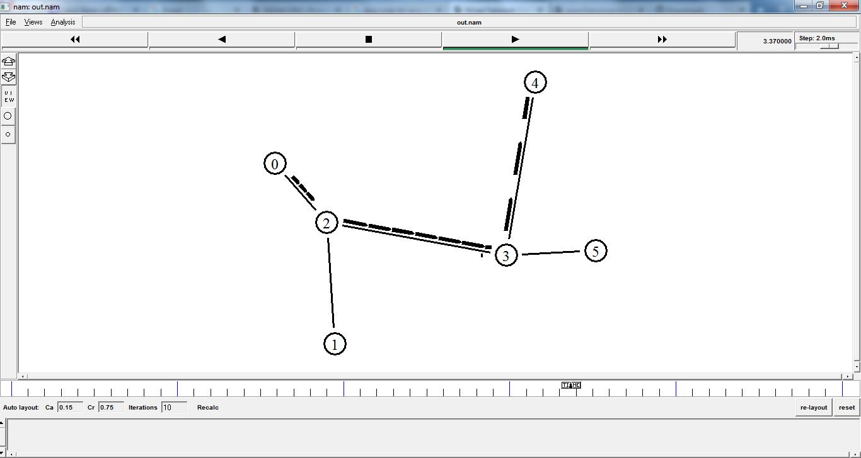

RESULT:
Thus Congestion control in TCP using NS2 Simulator was executed and verified sucessfully.

NL 48 PITS/CSE/III YR/NL

CS8581 NETWORKS LABORATORY

VIVA QUESTIONS
1. Compare Flow control and Congestion Control.

2. Give the general principles of congestion

3. List some factors that cause congestion in Transport layer.

- Name and write about the technique used when a congested node stops receiving data from the immediate upstream node or nodes.

5. What are the two algorithms that control Congestion?

STAFF SIGNATURE

NL 49 PITS/CSE/III YR/NL

 | CS8581 NETWORKS LABORATORY
Ex.No :7 | STUDY OF TCP/UDP PERFORMANCE USING SIMULATION TOOL
DATE :

INTRODUCTION

- A computer network is a service that uses to share audio, video and photo and other data between the laptops, computers and any smart devices can connect to the network. It is also used to share the network resources like the printer.

- TCP and UDP protocols are approved to work on transport layer of a network. They handle with the data differently.

- TCP uses a connection oriented way to handle the data thus provides a very reliable way of handling messaging or information where it guarantees the delivery of the message.

- If there is some error in the transmission, the packet will be automatically re-sent over the network .

- UDP utilizes a simple transport model with a minimum of protocol technique. Computer applications with the UDP can transmit messages, in this situation, indicated as an datagrams, and also can send voices and videos .

- A performance comparison among UDP and TCP in MANET to evaluate the conduct of DSDV, DSR, and AODV protocols.

- The comparison between the protocols using NS2 to analyze protocols performance, where the results have shown that TCP in some mobility models is outperformed the UDP in terms of throughput.

- Also, the DSDV has shown lowest delay in all simulation for UDP.

- This study has provided performance assessment among DSR and AODV protocols in the mobility paradigm with UDP and TCP traffic sources.

- The results have been referred that the performance of AODV protocol is outperformed the performance of DSR protocol in the high mobility environments.

- Moreover, a performance comparison among UDP and TCP for TORA and OLSR in various mobility conditions have been provided.

- NS2 simulator is used to evaluate and analyze protocols performance based on the various performance measures like throughput, packet delivery percentage and end-to-end delay.

- The results have referred that TCP is outperformed UDP in terms of the throughput.

- Furthermore, TORA protocol in UDP is outperformed TCP in the PDR.

NL 50 PITS/CSE/III YR/NL

CS8581 NETWORKS LABORATORY

- However, there are many comparisons of routing protocols but still, there is a need to carefully study the protocol performance in several scenarios.

- For instance, an improper routing protocol for the specific network scenario result in degraded performance of that network.

- Wherein it have been presented a comparison between OLSR and LAR protocols for detecting the forest fire and results showed that LAR has outperformed OLSR.

- In this regard, a review of routing protocols has been presented in the surveillance of the forest fire and study the performance of those protocols in this disaster .

- Moreover, a comparison among DSDV, AODV, and DSR has been presented with a different number of nodes.

- This study addresses a comparative study between the performance of UDP and TCP tunnel connections in OpenVPN.

- Two scenarios have been simulated to test two mechanisms of VPN tunnelling.

- The results have shown that the tunnel of UDP uses the link better than TCP tunnel and give improved transfer in terms of the speed and the time.

- However, there is still a need to clearly study the performance of UDP and TCP in different network metrics and scenarios.

- Thus, this study provides the performance comparison among UDP and TCP to precisely study the performance of these two protocols with different packet size and bandwidth.

COMPARISON STUDY BETWEEN TCP AND UDP

- TCP is represented as a connection-oriented protocol, TCP presents end-to-end communications.

- Moreover, when the communication is created among the transmitter and receiver, the data can be send over that communication.

- While the UDP is a simple connectionless protocol. UDP does not constitute a dedicated end-to-end communication among the

transmitter and the receiver before the real communication takes place.

- However, the data is being transported in one trend from the transmitter to the receiver with

no need to verifying the receiver case. Figure shows the segment fields of TCP and UDP.
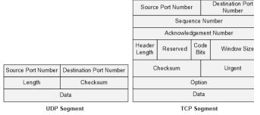

NL 51 PITS/CSE/III YR/NL

CS8581 NETWORKS LABORATORY

- The UDP and TCP are various on the basic operations and applications.

- The differences in the data transmission, the TCP presents ordered and reliable delivery of data from the user to the server and vice versa.

- UDP considered as a connectionless protocol and does not provide the reliable delivery for the data. UDP and TCP are various from each other in terms of the basic features for the data transmission.

- However, TCP is more reliable comparing to the UDP, where TCP uses the retransmissions and the message acknowledgment if there is some loss in the packets.

- Therefore, there is no losing data in the network. While in the case of UDP does not guarantee that the data has arrived to the receiver or not.

- Also, in UDP there is no retransmission, timeout and message acknowledgment. TCP transmits the messages in an order and these messages are received in the same order at the destination.

- If the packets of the data reach in the wrong order, TCP can reorder the data packets. Whilst in UDP, the sequence of the message is not maintained over the transmission. TCP records the data as a stream of bytes and sending the message as segments.

- The messages in UDP are sending as datagrams in the network.

- So, both of TCP and UDP have various approaches of sending and receiving the data . Figure shows a comparative among TCP and UDP.
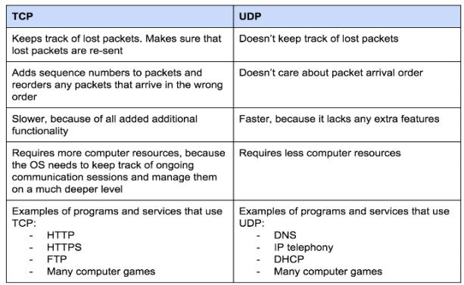

NL 52 PITS/CSE/III YR/NL

CS8581 NETWORKS LABORATORY

SIMULATION SCENARIOS

- NS2 is utilized simulator in this study to evaluate and analyze the behavior of both TCP and UDP protocols.

- This simulation has been presented two wired scenarios to carefully verify the behavior of these protocols.

- Where in the first scenario the bandwidth is varied from 0.1 Mb/ms to 0.5 Mb/ms and the packet size is fixed at 64 bytes.

- While in the second scenario the packet size is varied from 800 bytes to 1000 bytes and the bandwidth is fixed at 0.3 Mb/ms.

- Simulation parameters shows in table 1. The nodes number in this study is 8 and the simulation time is 64 second in both scenarios .

- Figure illustrates the wired simulation environment.
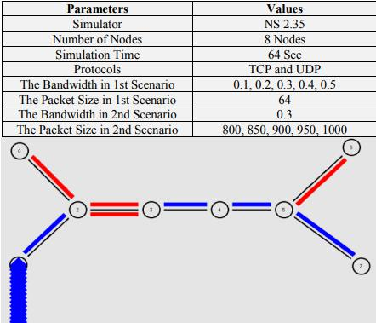

NL 53 PITS/CSE/III YR/NL

CS8581 NETWORKS LABORATORY

PERFORMANCE METRICS

- In the comparison, we have utilized various network behavior metrics among UDP and TCP.

- These metrics are applied to evaluate and analyze protocols performance

Packet Delivery Ratio (PDR)

- PDR is the percentage of data packets transported to the destination to those produced by the sources. PDR is calculated as follow:
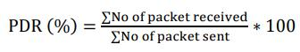

Average Throughput (TP)

- It is the bytes successfully received number and it is calculated as follow:

- TP = No. of Bytes Received ∗ 8 ∗ Simulation Time ∗ 1000 kbpsb

4Average End-to-End Delay (e2e delay)

- It is the mean time of the successfully transmitted data packet over the network from the source to the destination. It is computed as follow
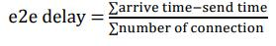

Packet Loss (PL)

- It is the difference among the data packets transmitted and the data packets received.

- It is calculated as follow: PL = No. of Data Packets Sent − No. of Data Packets Receive

NETWORK METRICS

- In this our simulation, there are two various kinds of network parameters which are varying through the simulation experiments:

- Bandwidth: It is the data number that transfer from the source to the destination.

- Packet size: A packet is the unit of data which is routed between the source and destination.

SIMULATION RESULTS AND DISCUSSION

- In this simulation, we have analyzed and compared the TCP and UDP protocols utilizing NS2 in two scenarios.

- The first scenario has been simulated in different bandwidth and in the second scenario we have used different packet size.

- According to the results obtained in the first scenario, the performance of both protocols has been much different from each other.

NL 54 PITS/CSE/III YR/NL

CS8581 NETWORKS LABORATORY

- Where in Figure 5 the TCP has achieved 700.71 of throughput and UDP has achieved 687.1 that means TCP receives data more than UDP.

- Figure 6 indicates the behavior of the protocols in the e2e delay, where TCP has been achieved average e2e delay to 0.62018 sec and UDP has been achieved 0.98376 sec.

- It is obvious, there is no huge difference between the protocols in e2e delay.

- In terms of PDR as shown in Figure 6, the behavior of TCP showed much better than UDP, where TCP has been obtained 100% of the network and UDP has obtained 4.04 of PDR.

- However, TCP has 0% of PL and UDP has 95.96 as shown in Figure 7.

- Therefore, the results in the first scenario have shown that TCP is much better than UDP in terms of all performance measures
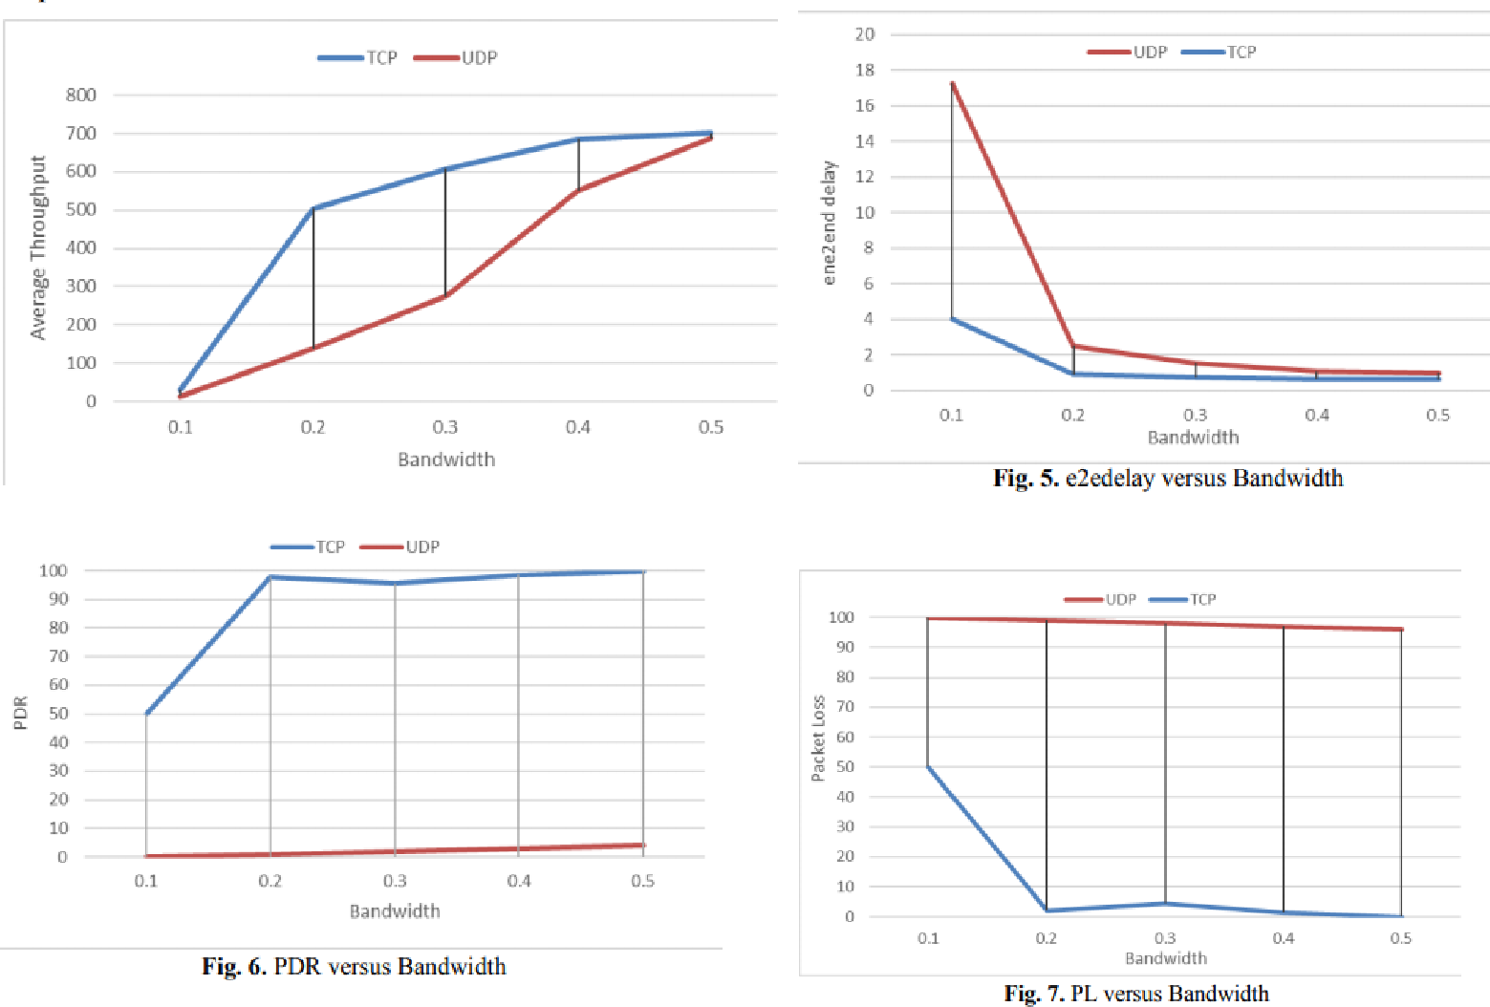

- In the second scenario, it has been used different packet size in both protocols.

- The results have shown that the behavior of TCP is outperformed behavior of UDP in mean throughput as shown in Figure 8, where TCP has 580.67 of throughput and UDP has 302.67.

- Figure 9 shows the performance of the protocols in average e2e delay, TCP has achieved 0.93883 sec and UDP has achieved 2.84602 sec.

- Thus, TCP performance is faster than UDP in send and receive the data. In Figure 10, the

performance of TCP is outperformed UDP in the PDR, where TCP has been achieved 95.7 value of

NL 55 PITS/CSE/III YR/NL

CS8581 NETWORKS LABORATORY

PDR and UDP has achieved 3 of PDR. However, Figure 11 illustrates the behavior of the protocols in PL, TCP has achieved 4.74 of PL and UDP has achieved 97 value of PL. Therefore, the results in the second scenario have shown that

- TCP is much better than UDP in terms of all performance metrics.
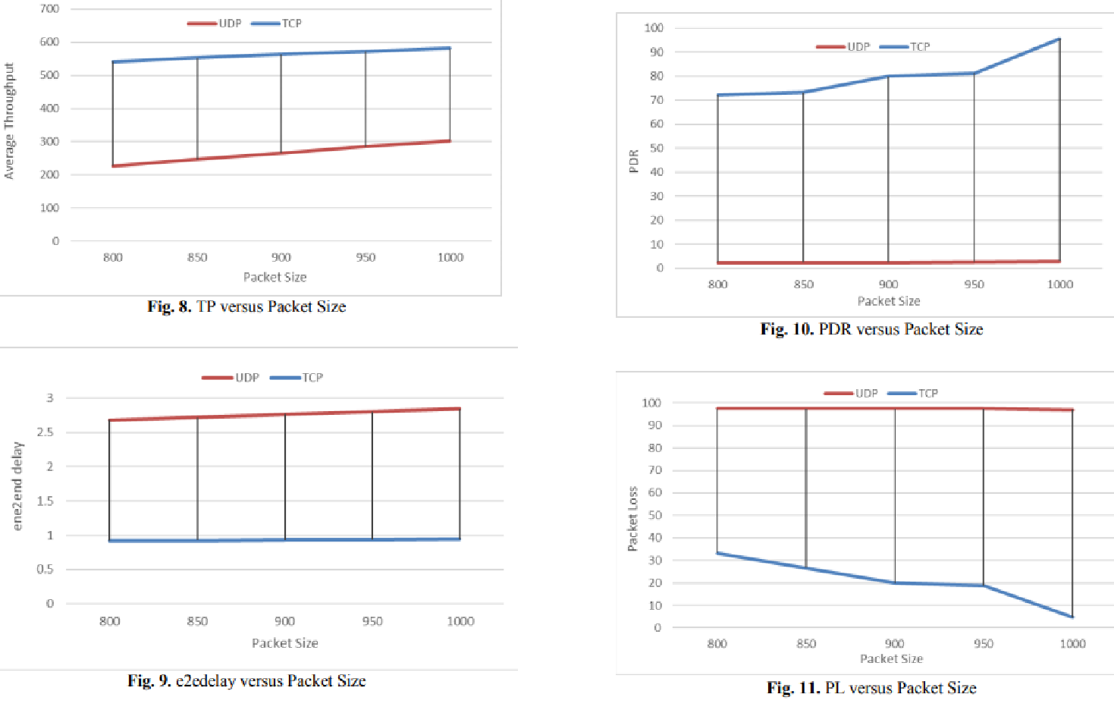

CONCLUSION

- TCP and UDP are a transportation layer protocols which are considered of the basic protocols of the internet. The performance of these protocols in various network parameters and scenarios is still not so clear.

- We have analyzed and compared the behavior of both TCP and UDP in two different scenarios to accurately determine which of these protocols is better.

- The simulation has been used NS2 to assess the behavior of TCP and UDP in varying packet size and bandwidth.

- These two protocols were measured in terms of the mean end-to-end delay, mean throughput, packet delivery percentage, and packet loss ratio. The results have shown that the performance of TCP is outperformed the UDP in both of the two scenarios.

- Therefore, we conclude that the TCP is more reliable and better than UDP in terms of all the performance measures.

NL 56 PITS/CSE/III YR/NL

CS8581 NETWORKS LABORATORY

VIVA QUESTIONS

1. Define simulation

2. Compare TCP and UDP

3. Define packet loss

4. When to use TCP and UDP?

5. Define bandwidth

STAFF SIGNATURE

NL 57 PITS/CSE/III YR/NL

CS8581 NETWORKS LABORATORY

Ex.No : 8(a) SIMULATION OF DISTANCE VECTOR ROUTING ALGORITHM DATE:

AIM

To simulate and study the Distance Vector routing algorithm using simulation.

THEORY

- Distance Vector Routing is one of the routing algorithm in a Wide Area Network for computing shortest path between source and destination.

- The Router is one main devices used in a wide area network. The main task of the router is Routing.

- It forms the routing table and delivers the packets depending upon the routes in the tableeither directly or via an intermediate devices.

- Each router initially has information about its all neighbors. Then this information will be shared among nodes.

ALGORITHM

- Create a simulator object

- Define different colors for different data flows

- Open a nam trace file and define finish procedure then close the trace file, and execute nam on trace file.

- Create n number of nodes using for loop

- Create duplex links between the nodes

- Setup UDP Connection between n(0) and n(5)

- Setup another UDP connection between n(1) and n(5)

- Apply CBR Traffic over both UDP connections

- Choose distance vector routing protocol to transmit data from sender to receiver.

- Schedule events and run the program.

PROGRAM ( Distance Vector)

set ns [new Simulator]

set nr [open thro.tr w]

$ns trace-all $nr set nf [open thro.nam w]

$ns namtrace-all $nf

proc finish { } {

NL 58 PITS/CSE/III YR/NL

CS8581 NETWORKS LABORATORY

global ns nr nf

$ns flush-trace

close $nf

close $nr

exec nam thro.nam &

exit 0

}

for { set i 0 } { $i < 12} { incr i 1 } {

set n($i) [$ns node]}

for {set i 0} {$i < 8} {incr i} {

$ns duplex-link $n($i) $n([expr $i+1]) 1Mb 10ms DropTail } $ns duplex-link $n(0) $n(8) 1Mb 10ms DropTail $ns duplex-link $n(1) $n(10) 1Mb 10ms DropTail

$ns duplex-link $n(0) $n(9) 1Mb 10ms DropTail

$ns duplex-link $n(9) $n(11) 1Mb 10ms DropTail

$ns duplex-link $n(10) $n(11) 1Mb 10ms DropTail

$ns duplex-link $n(11) $n(5) 1Mb 10ms DropTail

set udp0 [new Agent/UDP]

$ns attach-agent $n(0) $udp0

set cbr0 [new Application/Traffic/CBR]

$cbr0 set packetSize_ 500

$cbr0 set interval_ 0.005

$cbr0 attach-agent $udp0

set null0 [new Agent/Null]

$ns attach-agent $n(5) $null0

$ns connect $udp0 $null0

set udp1 [new Agent/UDP]

$ns attach-agent $n(1) $udp1

set cbr1 [new Application/Traffic/CBR]

$cbr1 set packetSize_ 500

$cbr1 set interval_ 0.005

$cbr1 attach-agent $udp1

set null0 [new Agent/Null]

$ns attach-agent $n(5) $null0

NL 59 PITS/CSE/III YR/NL

CS8581 NETWORKS LABORATORY

$ns connect $udp1 $null0

$ns rtproto DV

$ns rtmodel-at 10.0 down $n(11) $n(5)

$ns rtmodel-at 15.0 down $n(7) $n(6)

$ns rtmodel-at 30.0 up $n(11) $n(5)

$ns rtmodel-at 20.0 up $n(7) $n(6)

$udp0 set fid_ 1

$udp1 set fid_ 2

$ns color 1 Red

$ns color 2 Green

$ns at 1.0 "$cbr0 start"

$ns at 2.0 "$cbr1 start"

$ns at 45 "finish"

$ns run

OUTPUT
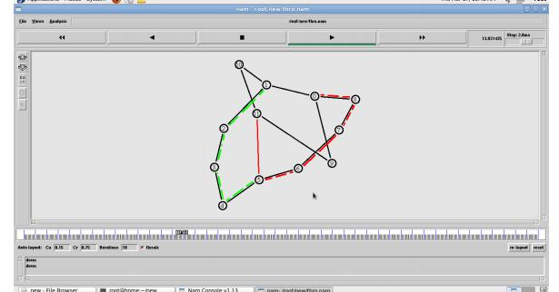

RESULT

Thus the Distance vector Routing Algorithm was simulated and studied.

NL 60 PITS/CSE/III YR/NL

CS8581 NETWORKS LABORATORY

Ex.No : 8(b) SIMULATION OF LINK STATE ROUTING ALGORITHM DATE:

AIM

- To simulate and study the link state routing algorithm using simulation.

THEORY

- In link state routing, each router shares its knowledge of its neighborhood with every other router in the internet work.

  - Knowledge about Neighborhood: Instead of sending its entire routing table a router sends info about its neighborhood only.

  - To all Routers: each router sends this information to every other router on the internet work not just to its neighbor .It does so by a process called flooding.

  - Information sharing when there is a change: Each router sends out information about the

neighbors when there is change.

PROCEDURE

- The Dijkstra algorithm follows four steps to discover what is called the shortest path tree(routing table) for each router

- The algorithm begins to build the tree by identifying its roots. The root router’s trees the router itself.

- The algorithm then attaches all nodes that can be reached from the root. The algorithm compares the tree’s temporary arcs and identifies the arc with the lowest cumulative cost.

- This arc and the node to which it connects are now a permanent part of the shortest path tree. The algorithm examines the database and identifies every node that can be reached from its chosen node.

- These nodes and their arcs are added temporarily to the tree.

- The last two steps are repeated until every node in the network has become a permanent part of

the tree.

ALGORITHM

- Create a simulator object

- Define different colors for different data flows

NL 61 PITS/CSE/III YR/NL

CS8581 NETWORKS LABORATORY

- Open a nam trace file and define finish procedure then close the trace file, and execute nam on trace file.
- Create n number of nodes using for loop

- Create duplex links between the nodes

- Setup UDP Connection between n(0) and n(3)

- Setup another UDP connection between n(1) and n(3)

- Apply CBR Traffic over both UDP connections

- Choose Link state routing protocol to transmit data from sender to receiver.

- Schedule events and run the program

PROGRAM

set ns [new Simulator]

set nf [open out.nam w]

$ns namtrace-all $nf

set tr [open out.tr w]

$ns trace-all $tr

proc finish {} {

global nf ns tr

$ns flush-trace

close $tr

exec nam out.nam &

exit 0

}

set n0 [$ns node]

set n1 [$ns node]

set n2 [$ns node]

set n3 [$ns node]

$ns duplex-link $n0 $n1 10Mb 10ms DropTail

$ns duplex-link $n1 $n3 10Mb 10ms DropTail

$ns duplex-link $n2 $n1 10Mb 10ms DropTail

$ns duplex-link-op $n0 $n1 orient right-down

$ns duplex-link-op $n1 $n3 orient right

$ns duplex-link-op $n2 $n1 orient right-up

NL 62 PITS/CSE/III YR/NL

CS8581 NETWORKS LABORATORY

set tcp [new Agent/TCP]

$ns attach-agent $n0 $tcp

set ftp [new Application/FTP]

$ftp attach-agent $tcp

set sink [new Agent/TCPSink]

$ns attach-agent $n3 $sink

set udp [new Agent/UDP]

$ns attach-agent $n2 $udp

set cbr [new Application/Traffic/CBR]

$cbr attach-agent $udp

set null [new Agent/Null]

$ns attach-agent $n3 $null

$ns connect $tcp $sink

$ns connect $udp $null

$ns rtmodel-at 1.0 down $n1 $n3

$ns rtmodel-at 2.0 up $n1 $n3

$ns rtproto LS

$ns at 0.0 "$ftp start"

$ns at 0.0 "$cbr start"

$ns at 5.0 "finish"

$ns run

OUTPUT
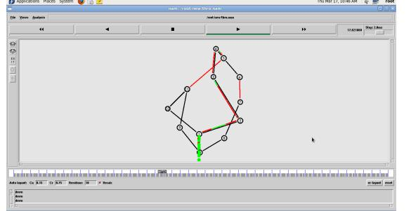

RESULT

Thus the Link State Routing Algorithm was Simulated and studied.

NL 63 PITS/CSE/III YR/NL

CS8581 NETWORKS LABORATORY

VIVA QUESTIONS

1. What is routing?

2. What is dynamic routing?

3. Compare link state and distance vector routing

4. What are all the route metric used in Link state routing?

5. Compare connection oriented and connection less protocols.

Staff Signature

NL 64 PITS/CSE/III YR/NL

CS8581 NETWORKS LABORATORY

Ex.No : 9 PERFORMANCE EVALUATION OF ROUTING PROTOCOLS USING SIMULATION TOOL DATE:

AIM

To evaluate the performance of routing protocols using NS2

THEORY

Simulation of DSR Routing

- DSR is a reactive routing protocol used in Adhoc network.

- In DSR route is discovered using Route Discovery phase, which broadcast a RREQ(Route Request) Packet.

- Destination of receiving of this packet send reply by sending RREP(Route Reply) packet.

ALGORITHM

1. Create a simulator object

2. Define different colors for different data flows

3. Open a nam trace file and define finish procedure then close the trace file, and execute nam on trace file.

4. Create n number of nodes using for loop

5. Create duplex links between the nodes

6. Setup UDP Connection between n(0) and n(3)

7. Setup another UDP connection between n(1) and n(3)

8. Apply CBR Traffic over both UDP connections

9. Choose Link state routing protocol to transmit data from sender to receiver. 10. Schedule events and run the program

PROGRAM
# Define options
set val(chan) | Channel/WirelessChannel ;# channel type
set val(prop) | Propagation/TwoRayGround ;# radio-propagation model
set val(netif) | Phy/WirelessPhy |  | ;# network interface type
set val(mac) | Mac/802_11 | ;# MAC type
set val(ifq) | CMUPriQueue | ;# interface queue type
set val(ll) | LL | ;# link layer type
set val(ant) | Antenna/OmniAntenna |  | ;# antenna model
set val(ifqlen) | 50 | ;# max packet in ifq
set val(nn) | 10 | ;# number of mobilenodes
NL 65 |  |  | PITS/CSE/III YR/NL

CS8581 NETWORKS LABORATORY

set val(rp) |  | DSR | ;# routing protocol
set val(x) |  | 500 | ;# X dimension of topography
set val(y) |  | 400 | ;# Y dimension of topography
set val(stop) |  | 50 | ;# time of simulation end
set ns | [new Simulator]
set tracefd |  | [open simple-dsdv.tr w]
set windowVsTime2 [open win.tr w]
set namtrace |  | [open simwrls.nam w]
$ns trace-all $tracefd
$ns use-newtrace

$ns namtrace-all-wireless $namtrace $val(x) $val(y)

# set up topography object

set topo [new Topography]

$topo load_flatgrid $val(x) $val(y)

create-god $val(nn)

#

- Create nn mobilenodes [$val(nn)] and attach them to the channel.

  - configure the nodes

$ns node-config -adhocRouting $val(rp) \

-llType $val(ll) \

-macType $val(mac) \

-ifqType $val(ifq) \

-ifqLen $val(ifqlen) \

-antType $val(ant) \

-propType $val(prop) \

-phyType $val(netif) \

-channelType $val(chan) \

-topoInstance $topo \

-agentTrace ON \

-routerTrace ON \

-macTrace OFF \

-movementTrace ON

for {set i 0} {$i < $val(nn) } { incr i } {

set node_($i) [$ns node]

}

for {set i 0} {$i < $val(nn)} {incr i} {

$node_($i) set X_ [expr rand()*500]

$node_($i) set Y_ [expr rand()*400]

$node_($i) set Z_ 0

}

# Generation of movements

NL 66 PITS/CSE/III YR/NL

CS8581 NETWORKS LABORATORY

#$ns at 10.0 "$node_(0) setdest 250.0 250.0 3.0"

#$ns at 15.0 "$node_(1) setdest 45.0 285.0 5.0"

#$ns at 110.0 "$node_(0) setdest 480.0 300.0 5.0"

  - Set a TCP connection between node_(0) and node_(1) set tcp [new Agent/TCP/Newreno]

$tcp set class_ 2

set sink [new Agent/TCPSink] $ns attach-agent $node_(0) $tcp $ns attach-agent $node_(9) $sink $ns connect $tcp $sink

set ftp [new Application/FTP] $ftp attach-agent $tcp

$ns at 2.0 "$ftp start"

for {set i 0} {$i<$val(nn)} {incr i} { $ns initial_node_pos $node_($i) 30
}

- Telling nodes when the simulation ends

for {set i 0} {$i < $val(nn) } { incr i } {

$ns at $val(stop) "$node_($i) reset";

}

# ending nam and the simulation

$ns at $val(stop) "$ns nam-end-wireless $val(stop)"

$ns at $val(stop) "stop"

$ns at 150.01 "puts \"end simulation\" ; $ns halt"

proc stop {} {

global ns tracefd namtrace

$ns flush-trace

close $tracefd

close $namtrace

exec nam simwrls.nam &

}
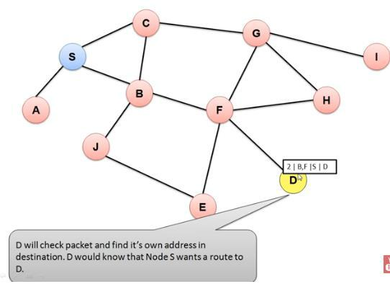

$ns run

Output

NL 67 PITS/CSE/III YR/NL

CS8581 NETWORKS LABORATORY

SIMULATION OF DSDV

THEORY

- Destination Sequenced Distance Vector Routing protocol is a modified version of Bellman Ford Algorithm and is based upon the concepts of Distance Vector Routing.

- In Distance Vector` Routing(DVR), each node broadcasts a table containing its distance from nodes which are directly connected and based upon this, other nodes broadcasts the updated routing.
Those nodes which are unreachable directly are labelled as “infinite”.

- But, this updation of routing tables keeps on happening and an infinite loop is generated which is commonly known as Count-To-Infinity problem.

- To overcome this problem of count to infinity by generating sequence number in the routing table, every time the routing table is updated. The process of DSDV is same as that of Distance Vector Routing but an extra attribute of sequence number is added.

- A 3-node example for ad-hoc simulation with DSDV

- Define options

set val(chan) | Channel/WirelessChannel ;# channel type
set val(prop) | Propagation/TwoRayGround ;# radio-propagation model
set val(netif) | Phy/WirelessPhy |  |  | ;# network interface type
set val(mac) | Mac/802_11 |  | ;# MAC type
set val(ifq) | Queue/DropTail |  | ;# interface queue type
set val(ll) | LL | ;# link layer type
set val(ant) | Antenna/OmniAntenna |  |  | ;# antenna model
set val(ifqlen) | 50 |  | ;# max packet in ifq
set val(nn) | 3 | ;# number of mobilenodes
set val(rp) | DSDV |  | ;# routing protocol
set val(x) | 500 |  |  | ;# X dimension of topography
set val(y) | 400 |  |  | ;# Y dimension of topography
set val(stop) |  | 150 |  | ;# time of simulation end
set ns |  | [new Simulator]
set tracefd | [open simple-dsdv.tr w]
set windowVsTime2 [open win.tr w]
set namtrace | [open simwrls.nam w]
$ns trace-all $tracefd
$ns use-newtrace
$ns namtrace-all-wireless $namtrace $val(x) $val(y)
# set up topography object
set topo [new Topography]
$topo load_flatgrid $val(x) $val(y)
NL 68 |  |  |  | PITS/CSE/III YR/NL

CS8581 NETWORKS LABORATORY

create-god $val(nn)

#

- Create nn mobilenodes [$val(nn)] and attach them to the channel.

- configure the nodes

$ns node-config -adhocRouting $val(rp) \

-llType $val(ll) \

-macType $val(mac) \

-ifqType $val(ifq) \

-ifqLen $val(ifqlen) \

-antType $val(ant) \

-propType $val(prop) \

-phyType $val(netif) \

-channelType $val(chan) \

-topoInstance $topo \

-agentTrace ON \

-routerTrace ON \

-macTrace OFF \

-movementTrace ON

for {set i 0} {$i < $val(nn) } { incr i } {

set node_($i) [$ns node]

}

- Provide initial location of mobilenodes $node_(0) set X_ 5.0
$node_(0) set Y_ 5.0 $node_(0) set Z_ 0.0 $node_(1) set X_ 490.0 $node_(1) set Y_ 285.0 $node_(1) set Z_ 0.0 $node_(2) set X_ 150.0 $node_(2) set Y_ 240.0 $node_(2) set Z_ 0.0
- Generation of movements

$ns at 10.0 "$node_(0) setdest 250.0 250.0 3.0"

$ns at 15.0 "$node_(1) setdest 45.0 285.0 5.0"

$ns at 110.0 "$node_(0) setdest 480.0 300.0 5.0"

- Set a TCP connection between node_(0) and node_(1) set tcp [new Agent/TCP/Newreno]

$tcp set class_ 2

set sink [new Agent/TCPSink] $ns attach-agent $node_(0) $tcp $ns attach-agent $node_(1) $sink $ns connect $tcp $sink

NL 69 PITS/CSE/III YR/NL

CS8581 NETWORKS LABORATORY

set ftp [new Application/FTP]

$ftp attach-agent $tcp

$ns at 10.0 "$ftp start"

- Define node initial position in nam for {set i 0} {$i < $val(nn)} { incr i } {

- 30 defines the node size for nam $ns initial_node_pos $node_($i) 30
}

- Telling nodes when the simulation ends for {set i 0} {$i < $val(nn) } { incr i } {

$ns at $val(stop) "$node_($i) reset";

}

- ending nam and the simulation

$ns at $val(stop) "$ns nam-end-wireless $val(stop)"

$ns at $val(stop) "stop"

$ns at 150.01 "puts \"end simulation\" ; $ns halt"

proc stop {} {

global ns tracefd namtrace

$ns flush-trace

close $tracefd

close $namtrace

exec nam simwrls.nam &

}

$ns run

OUTPUT
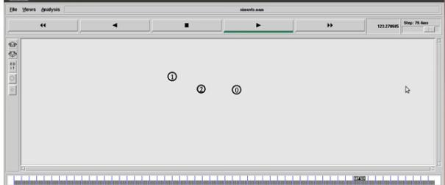

RESULT

Thus the performance of routing protocols was evaluated using NS2

NL 70 PITS/CSE/III YR/NL

CS8581 NETWORKS LABORATORY

VIVA QUESTIONS

1. List the routing protocols

2. What is flooding?

3. Define DSDV routing protocol

4. Define DSR routing protocol

5. Write about routing table

Staff Signature

NL 71 PITS/CSE/III YR/NL

CS8581 NETWORKS LABORATORY

Ex.No : 10 SIMULATION OF ERROR CORRECTION CODE DATE:

AIM

To implement error detection and error correction techniques.

THEORY

- The upper layers work on some generalized view of network architecture and are not aware of actual hardware data processing.

- Hence, the upper layers expect error-free transmission between the systems. Most of the applications would not function expectedly if they receive erroneous data. Applications such as voice and video may not be that affected and with some errors they may still function well.

- Data-link layer uses some error control mechanism to ensure that frames (data bit streams) are transmitted with certain level of accuracy.

- But to understand how errors is controlled, it is essential to know what types of errors may occur.

- CRC is a different approach to detect if the received frame contains valid data. This technique involves binary division of the data bits being sent.

- The divisor is generated using polynomials. The sender performs a division operation on the bits being sent and calculates the remainder.

- Before sending the actual bits, the sender adds the remainder at the end of the actual bits.

- Actual data bits plus the remainder is called a codeword. The sender transmits data bits as codewords.

ALGORITHM

- Get the input in the form of bits.

- Append 16 zeros as redundancy bits.

- Divide the appended data using a divisor polynomial.

- The resulting data should be transmitted to the receiver.

- At the receiver the received data is entered.

- The same process is repeated at the receiver.

- If the remainder is zero there is no error otherwise there is some error in the received bits

- Run the program.

NL 72 PITS/CSE/III YR/NL

CS8581 NETWORKS LABORATORY

PROGRAM

#include char m[50],g[50],r[50],q[50],temp[50];

void caltrans(int);

void crc(int);

void calram();

void shiftl();

int main()

{

int n,i=0;

char ch,flag=0;

printf("Enter the frame bits:");

while((ch=getc(stdin))!='\n')

m[i++]=ch;

n=i;

for(i=0;i<=16;i++)

g[i]='0';

g[0]=g[4]=g[11]=g[16]='1';

g[17]='\0';

printf("\ngenerator:%s\n",g);

crc(n);

printf("\n\nquotient:%s",q);

caltrans(n);

printf("\ntransmitted frame:%s",m);

printf("\nEnter transmitted frame:");

scanf("\n%s",m); printf("CRC checking\n");

crc(n); printf("\n\nlast remainder:%s",r);

for(i=0;i<=17;j++)

temp[j]=r[j]; }

q[n-16]='\0';

}

void calram()

{

int i,j;

for(i=1;i<=16;i++)

NL 73 PITS/CSE/III YR/NL

CS8581 NETWORKS LABORATORY

r[i-1]=((int)temp[i]-48)^((int)g[i]-48)+48;

}

void shiftl()

{

int i;

for(i=1;i<=16;i++)

r[i-1]=r[i];

}

void caltrans(int n)

{

int i,k=0;

for(i=n-16;i<n;i++)

m[i]=((int)m[i]-48)^((int)r[k++]-48)+48;

m[i]='\0';

}

OUTPUT

Enter the Frame Bits:

1011

The msg after appending 16 zeros: 10110000000000000000

The Transmitted frame is : 10111011000101101011

Enter the transmitted Frame 10111011000101101011

Received msg : 10111011000101101011

The Remainder is : 0000000000000000

Received frame is correct.

NL 74 PITS/CSE/III YR/NL

CS8581 NETWORKS LABORATORY

VIVA QUESTIONS

1. What are the types of errors?

2. What is Error Detection? What are its methods?

3. What is Redundancy?

4. What is CRC?

5. What is Checksum?

NL 75 PITS/CSE/III YR/NL

